Мекеме атауы №25 Жалпы орта білім беру мектеп

Аты – жөні __Хумарбек Айнур

Лауазымы Ағылшын тілі мұғалімі

Жұмысы өтілі 4 жылы

Санаты _____жоқ__________________________________________________

Пәні_______Ағылшын_тілі__________________________________________

Тақырыбы ___ “ Салыстырмалы және күшейтпелі шырайлары ” Қайталау сабағы

Сынып ____3 А____________________________________________________

**Lesson plan**

**Grade: 3 “A”**

**Date: ______________**

**Theme: Revision**

**Aim: -** To teach pupils to use “Comparative and Superlative adjectives ” in oral speech and in writing, to get full information through reading, listening and speaking.

* To continue our grammar “Adjective Comparison”
* To control their skills in making sentences with these adjective
* To enlarge their vocabulary .

**Knowledge tasks:** To explain the using of “Comparative and Superlative adjectives ”

**Developing tasks:** To develop pupil’s reading, speaking, listening, writing skills, abilities in classifying information into meaningful groups and selecting the main information.

**Technology:** communicative

**Type of the lesson:** revision

**Material needed:** pictures, cards, books, and cd

|  |  |  |  |  |
| --- | --- | --- | --- | --- |
| **Stage** | **Time** | **Activities** | **Interaction** | **Materials for subjects** |
| **Warm-up** | 2m | **Greeting.**  Good morning children! Sit down, please.  Who is on duty today?  What day is it today?  What date is it today?  What is the weather like today?  What season is it now? | T- S |  |
| **Making groups** | 5m | Pupils take a card with a sentence. If it in Comparative adjective he or she will be in “ Comparative adjective ” group. If it in Superlative adjective he or she will be in “Superlative adjective” group | S  T-S | The cards arrive in the hat |
| **Checking home-task** | 3m | Teacher gives cross word for adjectives pupils put the right adjectives  (Интерактивті тақта ) | S | Students write the adjectives then reading their pronunciation |
| **Presentation** | 10m | Pupils work in pairs they make a information for the comparison adjectives | S | Students explain the rules |
| **Sing a song** | 3m | “Saturday was the best of all” | T-S |  |
| **Wrting practice.** | 7m | Teacher gives tasks each groups and pupils check each other.  1. Complete the sentences. Use the comparative forms of the long adjectives.  1. Gold is____ than silver. (expensive)  2. Reality TV programmes are _____than chat shows. (interesting)  3. Science is difficult but Mathsis . (difficult)  4. I think that Halle Berry is_______ than Sharon Stone. (beautiful)  5. Tigers are _______ than crocodiles. (dangerous)  **2**  Complete the sentences. Use the superlative forms of the long adjectives.  1. Bears are__________the animals. (dangerous)  2. Baiterek is one of the _____ cities in the Kazakhstan. (beautiful)  3. The Bugatti Veyron is the______ and car. (expensive)  4. American Idol is______ the TV show in America. (popular)  5. Bungee jump is one of_______the adventures. (exciting) | S | Pupil’s write the comparative and superlative adjectives . Then they change their cards |
| **Speaking practice** | 10m | Teacher gives some information then pupils describing this information.  C:\Users\Учитель\Downloads\байтерек (1).jpg C:\Users\Учитель\Downloads\Алатауjpg.jpg C:\Users\Учитель\Downloads\зпавлодар.jpg  Astana 700,000 Almaty 1,200,000 Pavlodar 350,000p   1. The biggest city is Almaty | S | Pupils use the adjectives then they speak about this information |
| **Home task** | 2m | Revision of the Comparative and Superlative adjectives | T-S |  |
| **Reflection** | 3m | Do you like the lesson? Why? What do you learn? Teacher gives paper pupils write their likes or dislikes. |  |  |
| **Conclution**  **(giving marks)** |  |  | T | Teacher gives the marks |

№25 жалпы орта білім беру мектебі

**Ашық сабақ**

**Тақырыбы: Revision**

**“Comparative and Superlative adjectives”**

**Сынып: 3«А»**

**Мұғалім: Хумарбек Айнур**

2013-2014 оқу жылы

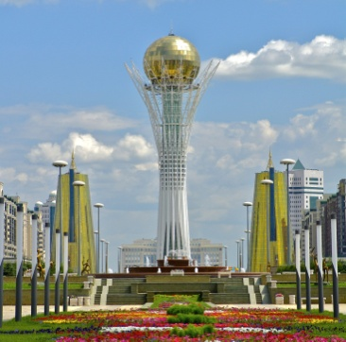 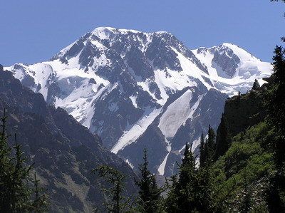 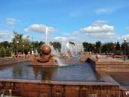

Astana Almaty Pavlodar

700,000 people 1,200,000 people 350,000 people

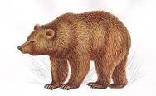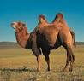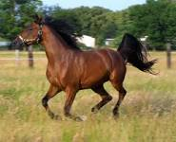

a bear a camel a horsе