**Вариант 1.**

Соедини растения и их названия. Раскрась только культурные растения.

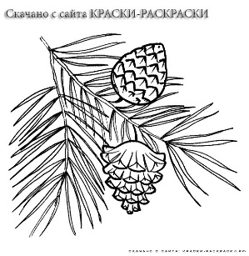 [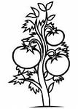](http://yandex.kz/images/search?viewport=wide&text=%D1%80%D0%B0%D1%81%D0%BA%D1%80%D0%B0%D1%81%D0%BA%D0%B0%20%D1%80%D0%B0%D1%81%D1%82%D0%B5%D0%BD%D0%B8%D1%8F&img_url=http://www.edupics.com/coloring-page-tomato-plant-p19182.jpg&pos=15&uinfo=sw-1440-sh-900-ww-1423-wh-775-pd-1-wp-16x10_1440x900&rpt=simage&_=1419571321313&pin=1) [](http://yandex.kz/images/search?img_url=http://www.numama.ru/images/photos/small/7c88acbad1fecb54743ce8133a908e82.jpg&uinfo=sw-1440-sh-900-ww-1423-wh-775-pd-1-wp-16x10_1440x900&_=1419571323249&viewport=wide&p=1&text=%D1%80%D0%B0%D1%81%D0%BA%D1%80%D0%B0%D1%81%D0%BA%D0%B0%20%D1%80%D0%B0%D1%81%D1%82%D0%B5%D0%BD%D0%B8%D1%8F&pos=42&rpt=simage&pin=1)

камыш подсолнух помидор

[](http://yandex.kz/images/search?viewport=wide&text=%D1%80%D0%B0%D1%81%D0%BA%D1%80%D0%B0%D1%81%D0%BA%D0%B0%20%D1%80%D0%B0%D1%81%D1%82%D0%B5%D0%BD%D0%B8%D1%8F&img_url=http://www.childrensland.ru/files/raskraski/rasteniya/rasteniya2.jpg&pos=16&uinfo=sw-1440-sh-900-ww-1423-wh-775-pd-1-wp-16x10_1440x900&rpt=simage&_=1419571321313&pin=1) **[](http://yandex.kz/images/search?img_url=http://raskraska.ucoz.ru/_nw/8/s56295389.jpg&uinfo=sw-1440-sh-900-ww-1423-wh-775-pd-1-wp-16x10_1440x900&_=1419571323249&viewport=wide&p=1&text=%D1%80%D0%B0%D1%81%D0%BA%D1%80%D0%B0%D1%81%D0%BA%D0%B0%20%D1%80%D0%B0%D1%81%D1%82%D0%B5%D0%BD%D0%B8%D1%8F&pos=43&rpt=simage&pin=1)** [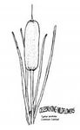](http://yandex.kz/images/search?viewport=wide&text=%D1%80%D0%B0%D1%81%D0%BA%D1%80%D0%B0%D1%81%D0%BA%D0%B0%20%D1%80%D0%B0%D1%81%D1%82%D0%B5%D0%BD%D0%B8%D1%8F&img_url=http://www.nps.gov/plants/color/northwest/imgs/Tyla1f.gif&pos=23&uinfo=sw-1440-sh-900-ww-1423-wh-775-pd-1-wp-16x10_1440x900&rpt=simage&_=1419571321313&pin=1)

земляника сосна тыква

**Вариант 2**

Найди, к какой группе относится растение. Под каждым рисунком поставь букву **Д** – если это дикорастущее растение или букву **К** – если растение культурное.

[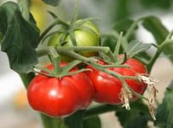](http://yandex.kz/images/search?img_url=http://www.supersadovnik.ru/site_images/00000053/00060679.jpg&uinfo=sw-1440-sh-900-ww-1423-wh-775-pd-1-wp-16x10_1440x900&_=1419566403338&viewport=wide&p=2&text=%D0%B4%D0%B8%D0%BA%D0%BE%D1%80%D0%B0%D1%81%D1%82%D1%83%D1%89%D0%B8%D0%B5%20%D1%80%D0%B0%D1%81%D1%82%D0%B5%D0%BD%D0%B8%D1%8F&pos=68&rpt=simage&pin=1) [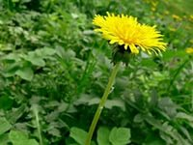](http://yandex.kz/images/search?viewport=wide&text=%D0%B4%D0%B8%D0%BA%D0%BE%D1%80%D0%B0%D1%81%D1%82%D1%83%D1%89%D0%B8%D0%B5%20%D1%80%D0%B0%D1%81%D1%82%D0%B5%D0%BD%D0%B8%D1%8F&img_url=http://img1.liveinternet.ru/images/attach/c/5/84/937/84937257_oduvanchik1.jpg&pos=0&uinfo=sw-1440-sh-900-ww-1423-wh-775-pd-1-wp-16x10_1440x900&rpt=simage&_=1419566389247&pin=1) [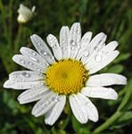](http://yandex.kz/images/search?viewport=wide&text=%D0%B4%D0%B8%D0%BA%D0%BE%D1%80%D0%B0%D1%81%D1%82%D1%83%D1%89%D0%B8%D0%B5%20%D1%80%D0%B0%D1%81%D1%82%D0%B5%D0%BD%D0%B8%D1%8F&img_url=http://cs9379.vk.me/u7850276/a_e7d076c4.jpg&pos=20&uinfo=sw-1440-sh-900-ww-1423-wh-775-pd-1-wp-16x10_1440x900&rpt=simage&_=1419566389247&pin=1) [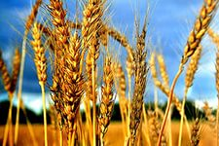](http://yandex.kz/images/search?viewport=wide&text=%D0%BF%D1%88%D0%B5%D0%BD%D0%B8%D1%86%D0%B0%20%D1%84%D0%BE%D1%82%D0%BE&img_url=http://i247.photobucket.com/albums/gg158/MDA2008/794915355_6e0065590c.jpg&pos=2&uinfo=sw-1440-sh-900-ww-1423-wh-775-pd-1-wp-16x10_1440x900&rpt=simage&_=1419570651012&pin=1) [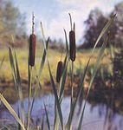](http://yandex.kz/images/search?viewport=wide&text=%D0%B4%D0%B8%D0%BA%D0%BE%D1%80%D0%B0%D1%81%D1%82%D1%83%D1%89%D0%B8%D0%B5%20%D1%80%D0%B0%D1%81%D1%82%D0%B5%D0%BD%D0%B8%D1%8F&img_url=http://rund.110mb.com/praktika/podvodrast/pics/pict095.jpg&pos=15&uinfo=sw-1440-sh-900-ww-1423-wh-775-pd-1-wp-16x10_1440x900&rpt=simage&_=1419566389247&pin=1)

[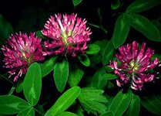](http://yandex.kz/images/search?viewport=wide&text=%D0%B4%D0%B8%D0%BA%D0%BE%D1%80%D0%B0%D1%81%D1%82%D1%83%D1%89%D0%B8%D0%B5%20%D1%80%D0%B0%D1%81%D1%82%D0%B5%D0%BD%D0%B8%D1%8F&img_url=http://kolyan.net/uploads/posts/2010-03/1268309999_16.jpeg&pos=5&uinfo=sw-1440-sh-900-ww-1423-wh-775-pd-1-wp-16x10_1440x900&rpt=simage&_=1419566389247&pin=1) [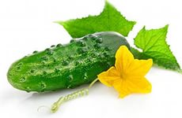](http://yandex.kz/images/search?viewport=wide&text=%D0%BE%D0%B3%D1%83%D1%80%D0%B5%D1%86&img_url=http://www.by.all.biz/img/by/catalog/47198.jpeg&pos=1&uinfo=sw-1440-sh-900-ww-1423-wh-775-pd-1-wp-16x10_1440x900&rpt=simage&_=1419570721648&pin=1) [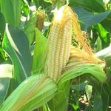](http://yandex.kz/images/search?viewport=wide&text=%D0%BA%D1%83%D0%BA%D1%83%D1%80%D1%83%D0%B7%D0%B0&img_url=http://s60.radikal.ru/i168/1011/f5/b94fce7c58d5.jpg&pos=5&uinfo=sw-1440-sh-900-ww-1423-wh-775-pd-1-wp-16x10_1440x900&rpt=simage&_=1419570779269&pin=1) [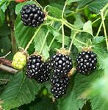](http://yandex.kz/images/search?source=related-0&img_url=http://chudo-ogorod.ru/wp-content/uploads/2009/10/ejevika-294x300.jpg&uinfo=sw-1440-sh-900-ww-1423-wh-775-pd-1-wp-16x10_1440x900&_=1419571067896&viewport=wide&text=%D0%B5%D0%B6%D0%B5%D0%B2%D0%B8%D0%BA%D0%B0&pos=1&rpt=simage&pin=1) [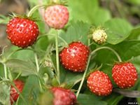](http://yandex.kz/images/search?viewport=wide&text=%D0%B7%D0%B5%D0%BC%D0%BB%D1%8F%D0%BD%D0%B8%D0%BA%D0%B0&img_url=http://open.az/uploads/posts/2011-06/1307944437_zemlyanika.jpg&pos=1&uinfo=sw-1440-sh-900-ww-1423-wh-775-pd-1-wp-16x10_1440x900&rpt=simage&_=1419570925650&pin=1)