Разработка урока «My favourite animals»

Class: 5 “А”
Theme of the lesson: - to develop communicative skills and abilities through different communicative activities.
- to encourage real use of language in group and pair work.
- To check students’ ability in using the words covered in the situation “Animals”.

Ход урока
- Ориентация
Teacher: Good morning teacher. I’m glad to see you.

- Мотивационно – целевой этап.
Teacher: Children, I have got the letter from London. This letter is written by Mr. Colin. Let’s listen to me. What does Colin tell us about in his letter?
Hi, Dear friends!
Сообщение темы: So, at the lesson today we will prepare for our trip to London Zoo.
Постановка цели: We’ll speak about our animals.

- Операционный этап.
- Фонетическая зарядка.
Listen and learn

I found a cow! How?
I found a bear! Where?
I found a hen! When?
I found a bear!
I found a hen! I found a cow! Wow!

- Речевая зарядка по теме.
- Write down the names of these animals.

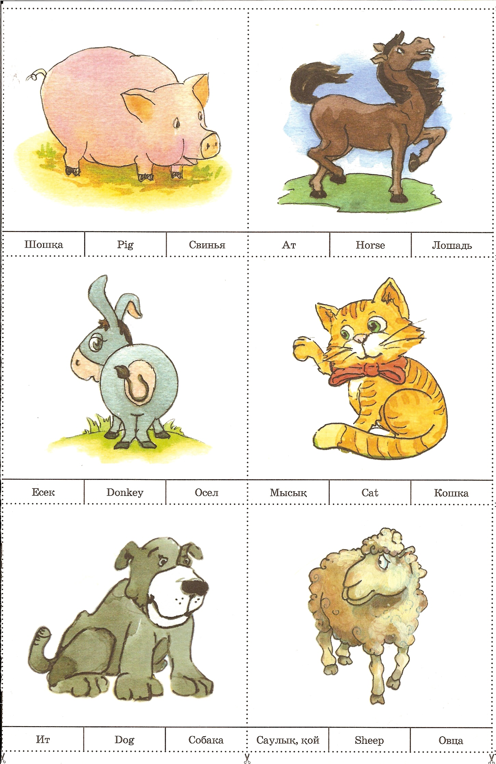

- Look at the blackboard and say,
Which are domestic animals and wild animals.
3. Развитие монологического умения.
а) Work in pair. Make up sentences.

What animals can do?

Animals | Swim | Run | Jump | Fly | Talk
Elephant
Bear
Tiger
Horse
Dog
Cat
Parrot

b) Listen and answer the questions. Work in group.

My favourite animals are tigers. They are orange, black and white. The tiger have got bodies, long tail and big teeth. Baby – tigers stay with their mothers for two years. Tigers live alone. They eat meat and fish. They hunt different animals. They usually hunt in the long grass. Tiger can swim. They live in Asia. They have got their own territory to live in. I think tigers are beautiful animals.

- What is Billy’s favourite animals?
- Which color is it?
- What does tiger have?
- What does he eat?
- What can they do?
- Where does he live?

- Контрольно – оценочный этап.
- Work in group.
Describe in your favourite animal

- Рефлексия.

Какие затруднения вы испытывали сегодня на уроке?
VI.Домашнее задание. Составить кроссворд по теме «Animals».
VII. Подведение итога по оцениванию.

