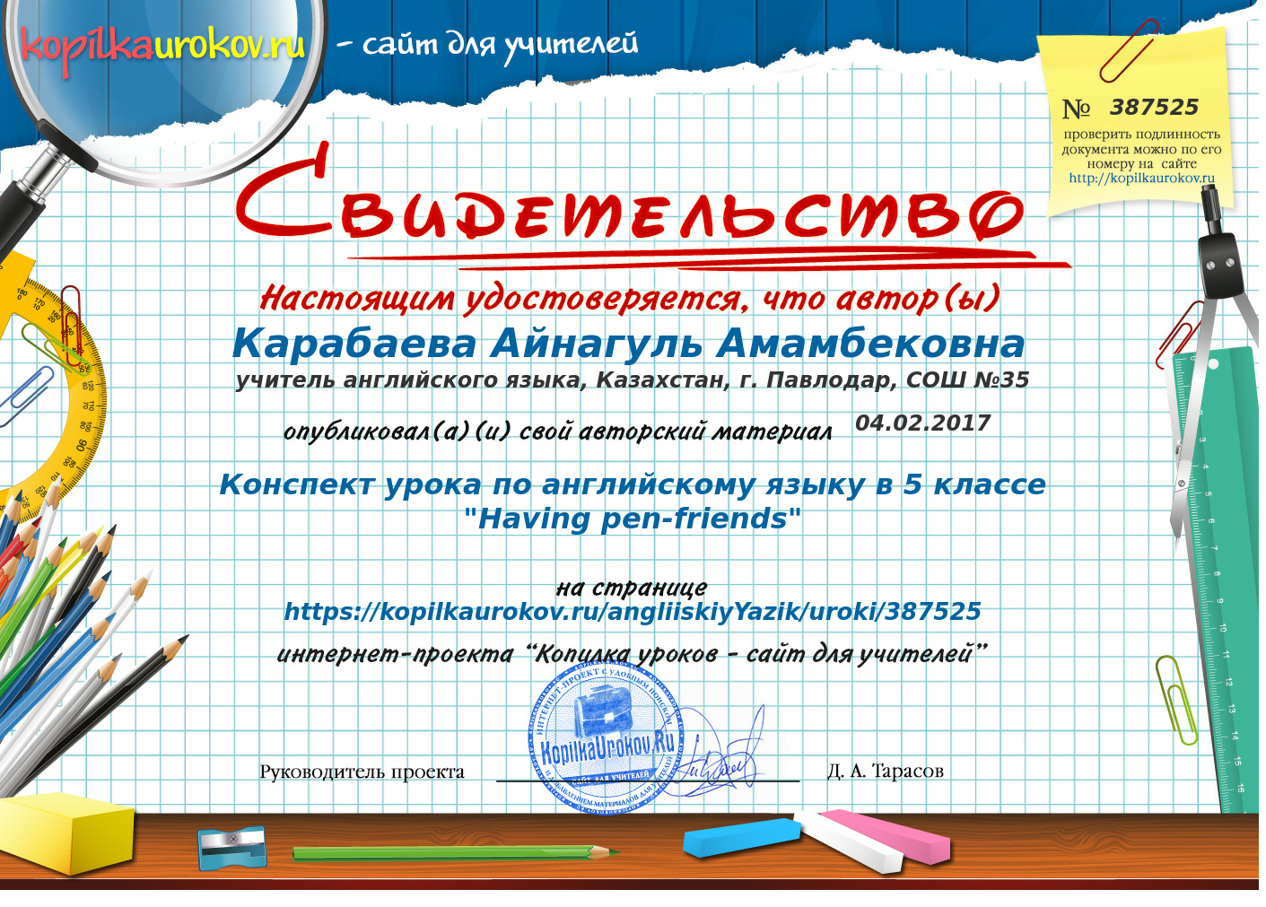

Пән: ағылшын 5 сынып
Сабақтың тақырыбы: Having pen-friends.
Сабақтың мақсаты: Оқушыларды жаңа лексикалық сөздермен
жұмыс істеуді, дос туралы айтып беруге үйрету
Достыққа, жолдастыққа тәрбиелеу
Есте сақтау қабілетін дамыту.
Сабақ әдісі: Сұрақ-жауап, сұхбат
Сабақ типі: Бекіту
Көрнекілігі: тақырыптық суреттер
Пән аралық байланыс: орыс тілі

Сабақ барысы:
I.Ұйымдастыру
А) амандасу
Б) жоқтарды белгілеу
II. Сабақтың тақырыбымен, мақсаттарымен таныстыру.
Our theme in our lesson is “Having pen-friends.”
V.Бекіту
Exercise 1 Read and mark the adjectives which describe your pen-friends and practice the pronunciation
Talkative clever
Kind hardworking
Gentle inactive
Silent interesting
Stupid unkind
Lazy helpful
Exercise 2 Talk to your partner
Do you have a pen-friend?
What can you say about your pen-friend?
Exercise 4 Match the Kazakh words with English and practice the pronunciation
Exercise 7 Now read the letters and compare them
May the 8th, 2003.
Dear Omar,
Hi! How are you? I hope good. I was very happy to get your letter. Thank you.
I haven’t been anywhere in summer. I have visited my grandmother in Bath. Bath is a beautiful town. It's very old. You have been to the USA, haven't you? I hope you have been to a lot of places of 'interest. What's your favourite sport? I love volleyball but I am not very good at it. I started an interesting book. I've been reading it since last week. What's your favourite sport? The weather is good here, it has been getting cooler. I like this weather and what about you?
Please, send me a photo of your family. I look forward to hearing from you very soon.
With love, your friend, Tom.

Hello! Where have you been? For a long time I haven't received any line from you. I have got a lot of news. I I've been to Italy and France. I enjoyed my trip. But it was a short-stay. I have been to different places of interest there. I have learned some words and phrases in Italian and French. In my town Bristol I could find 3-4 Italians and talk to them. I have enclosed a picture of my self. I t was my birthday last Saturday. It was a great day! Hove my birthday! I play the guitar. Do you play any musical instrument? Well, that's all for now. Please, write back soon. I really enjoy getting your letters.
With best wishes, your friend, Rodger
Exercise 8 read the letters and complete the following diagram

VI. Үйге тапсырма
Exercise 10
VII.Бағалау

