Discover Kazakhstan with a mobile App «Kazakhstan — the country of the great steppe»

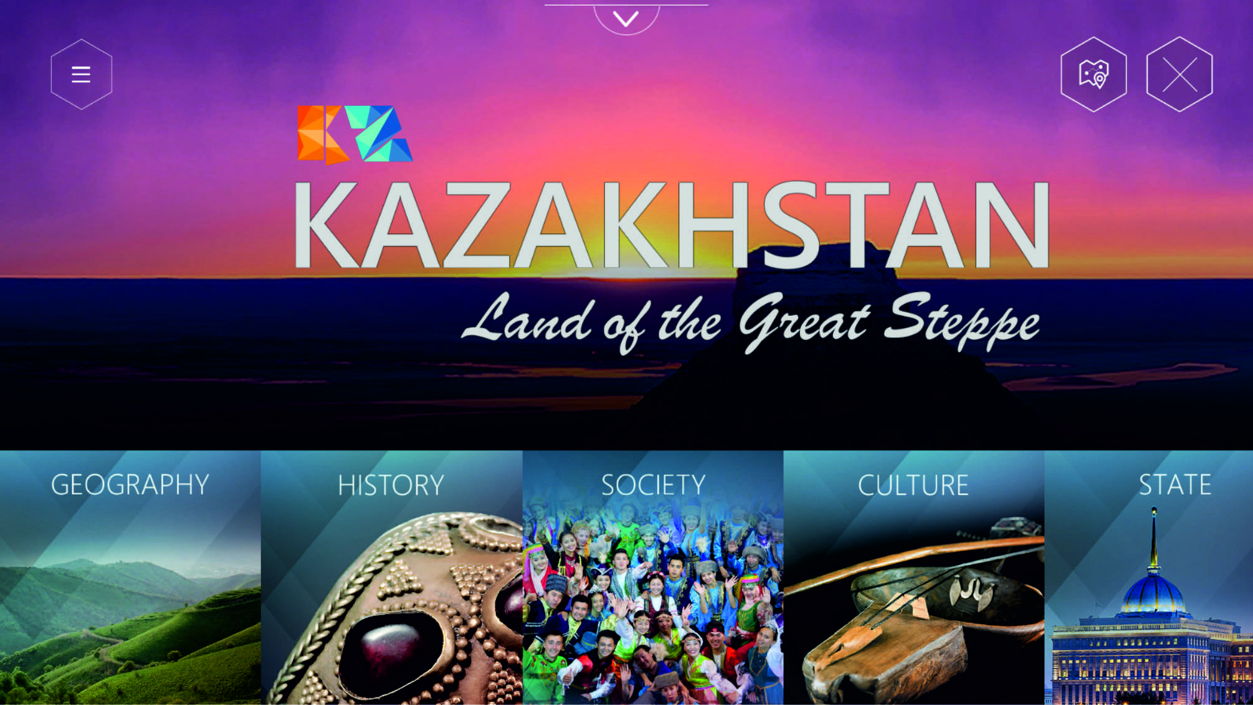
Presenting Your attention the mobile App “Kazakhstan — the Country of the great Steppe”, which is a true digital encyclopedia of Kazakhstan and covers a wide range of topics from geography, history and culture to the economy, tourism and international relations.
Contains hundreds of unique photographs and videos, 3D objects, panoramic tours, infographics and interactive maps in Kazakh, Russian and English.
The application will be indispensable for foreign nationals wishing to visit Kazakhstan, but also for a wide range of people — tourists, students, researchers, journalists and business representatives.
Available in the AppStore and PlayMarket, format Windows as well as the web version.
WELCOME TO KAZAKHSTAN!
Go to the page about the App: http://bit.ly/28PHIfG
Application of Kazakhstan “great Steppe.”
It is a cross-platform mobile application for all kinds of devices based on Windows, Apple, Android:
mobile phones;
tablets;
laptops;
desktop computers;

Also created the web version in the Internet site.
In total the App contains:
68 chapters, each of which has its own photo gallery. In total over 370 photos.
24 video;
12 objects in 3D;
20 panoramic photos (photos with 360);
12 interactive 3D graphics;
4 interactive 3D maps.
The application is designed as a universal tool:

The foreign Ministry employees for information and image work during meetings and presentations, for posting on the official web-site, and dissemination among the compatriots and the Kazakh Diaspora abroad and through the accounts of diplomatic missions of Kazakhstan in social networks.
For all Kazakhstanis application is a real digital encyclopedia about Kazakhstan, covering a wide range of topics. The App consists of 10 sections. It — geography, history, society, culture, government, international relations, economy, tourism, Astana and EXPO 2017.
Foreign nationals are especially interested in materials about the tourism, the investments in Kazakhstan and the exhibition “EXPO-2017”.
The project was implemented in three languages – Kazakh, Russian and English.
It can be argued that this is one of the first products in the field of digital solutions, which contains consolidated in one place such a unique information about Kazakhstan. Many photos and video materials are exclusive and have never been published before. Was set the bar very high technical and artistic quality requirements for each material.
Building the Application was attracted by a large team of professionals journalists, photographers, videographers, designers, programmers – only 80 people and 33 public and private organizations.
In the near future planned presentation and launch of a wide information campaign about the Application in the domestic and foreign media.

How to download and install the App:
Available in the open Internet anywhere in the world.
Installs on phones and tablets:
Icon Apple Store (for Apple devices) or Play store (for Samsung and others) – to enter in search of Kazakhstan the Land of the Great Steppe or Kazakhstan – the country of the great steppe in Russian (Kazakhstan and choose from the list of local applications) – then click Install.

For computers – download at the official web site of the Ministry of foreign Affairs mfa.kz (on the main page banner Kazakhstan Land of the Great Stepp)
Also convenient use of the App during presentations on large screens and plasma panels, laptops.

Links to download the apps
http://bit.ly/28PArej — link to the Kazakh version of the official page on the website of the MFA
http://bit.ly/28PHIfG link to the Russian version of the official page on the website of the MFA
http://bit.ly/28PkZza — link to the English version of the official page on the website of the MFA
https://itunes.apple.com/ru/app/kazakhstan-land-great-steppe/id1117366063?l=en&mt=8 link in AppStore
https://play.google.com/store/apps/details?id=kz.siveco.kazakhstan – to PlayMarket
http://mfa.gov.kz/mobile/demos/index.php — link to the online web version
http://bit.ly/28PckQP — download link of movies (all language versions and video formats)
https://www.youtube.com/watch?v=AEzdm6cEpLw – to the Youtube clip in the Kazakh language
https://www.youtube.com/watch?v=HzajL2ZKXoQ – to the Youtube clip in English
https://www.youtube.com/watch?v=ovg5VBHut5w — to the Youtube clip on the Russian language
https://mail.google.com/mail/u/0/#inbox/15586a40458684d1?projector=1 – to download the source file of the poster is A2 (all language versions) in the graphics program Corel Draw.
https://mail.google.com/mail/u/0/#inbox/15586a40458684d1?projector=1 – link to download a source file of a leaflet A5 (all language versions) in the graphics program Corel Draw.
https://www.dropbox.com/s/u5rr2nhdrwri6lv/%D0%90%D1%83%D0%B4%D0%B8%D0%BE%D1%80%D0%BE%D0%BB%D0%B8%D0%BA%D0%B8.zip?dl=0 —to download audio in Kazakh, Russian and English.

