Қазақстан Республикасы
Павлодар қаласы

5-9 СЫНЫПТАРҒА АРНАЛҒАН АҒЫЛШЫН ТІЛІ ПӘНІ БОЙЫНША ФУНКЦИОНАЛДЫҚ САУАТТЫЛЫҚҚА БАҒЫТТАЛҒАН ТАПСЫРМАЛАР ЖИНАҒЫ

Павлодар қаласының ағылшын тілі мұғалімдері:
«№ 17 ЖОББМ» КММ Мекежанова Д.Ж.
«№ 25 ЖОББМ» КММ Сачанова А.Н.
«№ 25 ЖОББМ» КММ Кожахметова К.Е.

2021 жыл
Андатпа
Бұл 5-9 сыныптарға арналған ағылшын тілі пәні бойынша функционалдық сауаттылыққа бағытталған тапсырмалар жинағы ағылшын тілінің оқыту сапасын көтерудің басты шарты ретінде оқушылардың функционалдық сауаттылығын қалыптастыру алынған жағдайда олар әрекеттік бағыт ұстанымына, оқушылардың коммуникативтік құзіреттерінің қалыптасуы ұстанымына, интерактивтік оқыту ұстанымына негізделуі қажет екендігін көрсетеді. Сонықтан да функционалдық сауаттылық оқушының ағылшын тілін әлеуметтік сұранымға сай қолдану мүмкіндіктерін арттырады. 5-9 сыныптарға арналған бұл тапсырмалар жинағы білім алушылардың функционалдық сауаттылығын дамыту дамытуға өз үлесін қосатыны сөзсіз. Ағылшын тілінің тілінің грамматикасын терең меңгерген білім алушы қоғамның кез келген саласында қиналмай қызмет етіп, өзінің функционалды сауаттылығын көрсете алады. Жинақ ағылшын тілі пәні мұғалімдері мен қосымша білім беру саласында қызмет етіп жүрген ұстаздарға пайдалы бола алады.

Аннотация
В данном сборнике заданий по предмету «Английский язык» направленных на развитие функциональной грамотности учащихся 5-9 классов. Сборник направлен на развитие и формирование функциональной грамотности учащихся на данном предмете. Пособие может быть полезно учителям английского языка и педагогам дополнительного образования. Оно поможет учителю найти возможности через активные формы обучения продолжить продуктивную работу над развитием функциональной грамотности у учащихся через урочную и внеурочную деятельность. Вместе с тем поможет развитию коммуникативных умений, а так же повысит навыки социальной конкурентоспособности учащихся.

Annotation
In this collection of tasks on the subject "English" aimed at the development of functional literacy of students in grades 5-9. The collection is aimed at the development and formation of functional literacy of students in this subject. The manual can be useful for teachers of English and teachers of additional education. It will help the teacher to find opportunities through active forms of learning to continue productive work on the development of functional literacy in students through classroom and extracurricular activities. At the same time, it will help the development of communication skills, as well as improve the skills of social competitiveness of students.

«Торайғыров Университеті» КАҚ  140008, Қазақстан Республикасы  Павлодар қаласы, Ломов к. 64  e-mail: www.tou.edu.kz | НАО «Торайгыров Университет»  140008, Республика Казахстан  г.Павлодар, ул. Ломова , 64  e-mail: www.tou.edu.kz

5-9 сыныптарға арналған ағылшын тілі пәні бойынша функционалдық сауаттылыққа бағытталған тапсырмалар жинағына
РЕЦЕНЗИЯ

5-9 сыныптарға арналған ағылшын тілі пәні бойынша функционалдық сауаттылыққа бағытталған тапсырмалар жинағы дидактикалық оқу құралын Павлодар қаласының «№17 ЖОББМ» КММ ағылшын тілі мұғалімі Д.Ж.Мекежанова, «№25 ЖОББМ» КММ ағылшын тілі мұғалімдері А. Н. Сачанова және К. Е. Кожахметова,құрастырды.
Функционалдық сауаттылықтың негізгі міндеті оқушылардың мәтіннен ақпарат алу, яғни оны түсіну, қысқарту, трансформациялау және ол ақпаратты ағылшын тілі сабақтарында еркін қолданып, қарым – қатынас жасау қабілетін қалыптастыру болып табылады. Құрастырушылар, әзірлеген оқу құралының мазмұны оқушылардың алдыңғы сыныптардағы жалпы білім беру пәндерін оқу кезінде алған білімдері мен дағдыларына негізделген. Аталған құрал ағылшын тілі пәнінде алынған базалық білімдерін кеңейтеді және тереңдетеді.
Сабақтарда 5-9 сынып балаларының жас ерекшеліктерін ескере отырып, мәтінмен жұмыс істеудің әртүрлі формалары мен әдістері қолданылады: ұсыныстарды салыстыру, парафраз, сәйкестендіру, сұрақтарға жауап беру, шығармашылық тапсырмалар және т.б. Құрылымдық тұрғыдан рецензияланған нұсқаулық беріледі: арнайы курстың өзектілігі, оның мақсаты мен міндеттері, күтілетін нәтижелері анықталды, оқу – тақырыптық жоспарлау және ағылшын тілінде оқытылатын материалдың мазмұны ұсынылды. «5-9 сыныптарға арналған ағылшын тілі бойынша функционалдық сауаттылыққа бағытталған тапсырмалар жинағы» атты әдістемелік құралы қазақстандық мектептің перспективалық мақсатына бағытталған және мектеп мұғалімдері үшін педагогикалық үдеріске енгізуге ұсынылған.

Филология ғылымдарының кандидаты, шет тілдер кафедрасының профессоры | Р. Саурбаев

«Павлодар қаласының М. Әуезов атындағы жалпы орта білім беру мектебі» КММ  140007, Қазақстан Республикасы  Павлодар қаласы, Ткачев к. 15  e-mail: sch42_pavlodar@mail.ru | КГУ «Средняя общеобразовательная школа города Павлодара имени М. Ауэзова»  140007, Республика Казахстан  г.Павлодар, ул. Ткачева 15  e-mail: sch42_pavlodar@mail.ru

РЕЦЕНЗИЯ
на дидактическое пособие
«Сборник заданий, направленных на функциональную грамотность по предмету Английский язык для 5-9 классов»

Дидактическое пособие составлено учителями английского языка КГУ «СОШ№17» г. Павлодара Мекежановой Д. Ж., учителями английского языка КГУ «СОШ№25» Сачановой А. Н и Кожахметовой К. Е.
Основной задачей функциональной грамотности является формирование у учащихся умения извлекать информацию из текста, т. е. понимать, сокращать, трансформировать его и свободно использовать лексику на уроках английского языка.
Данное методическое пособие составлено с целью развития функциональной грамотности учащихся 5-9 классов в чтении и понимании текста с использованием различных методов и приемов работы с текстом: сравнение предложений, перефразирование, идентификация, ответы на вопросы, творческие задания и др.
Содержание разработанного учебного пособия основано на знаниях и навыках, полученных учащимися при изучении общеобразовательных предметов школьного курса. Данное пособие расширяет и углубляет базовые знания, полученные учащимися на уроках английского языка. Пособие составлено с учетом возрастных особенностей учащихся 5-9 классов.
Актуальность данного пособия, его цель и задачи, ожидаемые результаты разработаны в соответствии с учебно – тематическим планированием и содержанием изучаемого материала на английском языке. Методическое пособие «Сборник заданий, направленных на функциональную грамотность по предмету Английский язык для 5-9 классов» ориентировано на перспективную цель школьной программы и рекомендовано учителям школ для использования на уроках английского языка.

Учитель английского языка высшей категории  КГУ «Средняя общеобразовательная школа города Павлодара имени М. Ауэзова» | С. Нихаева

5-9 сыныптарға арналған ағылшын тілі пәні бойынша
функционалдық сауаттылыққа бағытталған тапсырмалар жинағына
ТҮСІНДІРМЕ ЖАЗБА

Жалпы функциональдық сауаттылық деген ұғымды таратып айтар болсақ, адамдардың (жеке тұлғаның) әлеуметтік, мәдени, саяси және экономикалық қызметтерге белсене араласуы және өмір бойы білім алуына ықпал ететін базалық факторы. Ағылшын тілі сабағында оқушылардың функционалдық сауаттылығын арттыру дегеніміз – оқушының пәнді терең түсіну қабілетін дамыту, алған білімін сыныптан тыс жерде, кез келген жағдайда тиімді пайдалана білуін қамтамасыз ету. Мұндағы басшылыққа алынатын сапалар: белсенділік, шығармашылық тұрғыда ойлау, шешім қабылдай алу, өз кәсібін дұрыс таңдай алу, өмір бойы білім алуға дайын тұруы болып табылады.
Мектепте ағылшын тілін оқытудың түпкі нәтижесі ретінде қатысымдық, ақпараттық және проблемалардың шешімін табу құзіреттіліктерін қалыптастыруға қол жеткізудің басты тетігі – оқушының функционалдық сауаттылығын қалыптастыру. Өйткені функционалдық сауаттылық оқушының белгілі бір мәдени ортада өмір сүруі үшін қажетті деп саналатын және оның әлеуметтік қарым-қатынас жасауына пайдалы білім, білік, дағдылардың бірігуінен құралады.
Оқушылардың функционалдық сауаттылығын қалыптастыру ағылшын тілін оқытудың тұлғалық-әрекеттік бағдарын күшейту нәтижесінде жүзеге асады. Өйткені сауаттылыққа оқушы өз әрекетінің иесі – субъект дәрежесіне көтерілгенде толық қол жеткізеді.
Ағылшын тілінің оқыту сапасын көтерудің басты шарты ретінде оқушылардың функционалдық сауаттылығын қалыптастыру алынған жағдайда олар әрекеттік бағыт ұстанымына, оқушылардың коммуникативтік құзіреттерінің қалыптасуы ұстанымына, интерактивтік оқыту ұстанымына негізделуі қажет. Сонда ғана функционалдық сауаттылық оқушының ағылшын тілін әлеуметтік сұранымға сай қолдану мүмкіндіктерін арттырады. 5-9 сыныптарға арналған ағылшын тілі пәні бойынша функционалдық сауаттылыққа бағытталған тапсырмалар жинағы білім алушылардың функционалдық сауаттылығын дамыту дамытуға өз үлесін қосатыны сөзсіз. Ағылшын тілінің тілінің грамматикасын терең меңгерген білім алушы қоғамның кез келген саласында қиналмай қызмет етіп, өзінің функционалды сауаттылығын көрсете алады.
Жинақ 5, 6, 7, 8, 9 сыныптарға арналған оқу бағдарламасына сәйкес тапсырмалар білім алушылардың жас ерекшеліктері мен ағылшын тілін меңгеру деңгейін ескере отырып құрастырылған мәтіндерден, лексикалық, грамматикалық, сонымен қатар сәйкестендіру, сұрақтарға жауап сияқты тапсырмалардан тұрады. Әр сынып үшін құрастырылған тапсырмалар ооқу бағдарламасы негізге алынып, 9 тараудан тұрады. Әрбір тарау үшін құрылған тапсырмалар ағылшын тілі пәнінің Excel 5, 6, 7, 8, 9 оқу кітабына негізделіп сәкестендірілген. Сондай-ақ оқушылардың ағылшын тіліне деген жоғары қызығушылығының болуына байланысты әдістемелік жинақтағы ұсынылған мәтіндер мен тапсырмалар ағылшын тілі пәні бойынша білім алушылардың оқу сауаттылығына келіп соғары анық. Бұл әдістемелік құрал 5-9 сыныптарда сабақ беретін ағылшын тілі пәнінің ұстаздарына қосымша білім алушылармен жұмыс қолдану үшін пайдалы.

Contents.
- Annotation. 2
- Recommendation. 3
- Recommendation. 4
- Explanatory Note. 5
- Contents. 7
- Introduction. 9
- The 5 grade. 10
  - Unit 1. Home is my castle! 11
  - Unit 2. Describing people. 12
  - Unit 3. True friends. 13
  - Unit 4. World of Work. 14
  - Unit 5. Famous people in the UK. 16
  - Unit 6. Reading for Pleasure. 18
  - Unit 7. Why should we love animals? 20
  - Unit 8. Sport. 21
  - Unit 9. Holidays. 22
- The 6 grade. 24
  - Unit 1. Our class. 25
  - Unit 2. Helping and Heroes. 27
  - Unit 3. Our countryside. 29
  - Unit 4. Drama and Comedy. 31
  - Unit 5. Our health. 33
  - Unit 6. Travel and Holiday. 35
  - Unit 7. Reading for pleasure. 37
  - Unit 8. Our neighborhood. 39
  - Unit 9. Transport. 41
- The 7 grade. 43
7.1 Unit 1. Hobbies and Leisure. 44
7.2 Unit 2. Communication and Technology. 46
7.3 Unit 3. Holidays and Travel. 48
7.4 Unit 4. Space and Earth. 50
7.5 Unit 5. Reading for pleasure. 52
7.6 Unit 6. Entertainment and Media. 54
7.7 Unit 7. Natural disaster. 56
7.8 Unit 8. Healthy habits. 58
7.9. Unit 9. Clothes and Fashion. 60
8. The 8 grade. 62
  - Unit 1. Our World. 63
  - Unit 2. Daily life and Shopping. 65
  - Unit 3. Entertainment and the Media. 67
  - Unit 4. Sport, Health and Exercise. 69
  - Unit 5. Reading for pleasure. 71
  - Unit 6. The Natural World. 74
  - Unit 7. Travel and Transport. 76
  - Unit 8. Food and Drink. 78
  - Unit 9. The World of Work. 81
- The 9 grade. 84
  - Unit 1. Hobbies and Qualities. 85
  - Unit 2. Exercise and Sport. 87
  - Unit 3. Earth and our place on it. 89
  - Unit 4. Charities and conflict. 91
  - Unit 5. Reading for pleasure. 93
  - Unit 6. Music and Films. 95
  - Unit 7. Travel and Tourism. 98
  - Unit 8. Science and Technology. 100
- Glossary. 102
- Conclusion. 112
- References. 113

КІРІСПЕ
Жаңа ғасырды бастаған ұрпақ келер ұрпаққа қарыздар болып қалмас үшін қолдан келген игіліктерді жасайтыны анық. Қашанда білімі мол, рухани байлығы бар халықтың ұл-қыздары ешқашанда жүдемесі хақ. Сондықтан да біздің басты байлығымыз – білім.
Болашақ – білім мен ғылымға тәуелді болатыны айдан анық нәрсе. Қазіргі жас ұрпақтың білімі мен тәрбиесі қандай болса, елдің ертеңі де сондай дәрежеде болмақ. Сондықтан қоғам талабына сай, қоғамды көркейтетін, дамытатын, Қазақстан Республикасының ішкі және сыртқы істер байланысында мемлекеттің өркениеті үшін еңбек ететін, шетелдермен еркін ғылыми және мәдени қарымқатынастар жасай алатын, оқығанын өмірде қолдана алатын, ана тілімен қатар шет тілдерін жетік білетін, ұлтжанды азамат дайындау – бүгінгі ұстаз қауымының басты мақсаты.
Сауатсыздық дерті адамға кішкентай кезінен бастап жұғады. Әсіресе, бүлдіршінді жазу мен оқуға баули бастаған 1-ден 3-сыныпқа дейінгі аралықта пайда болады, яғни үшінші сынып білім алушысы ешқашан кітапқанаға бармаса, оқулықтан басқа ешқандай кітап оқымаса, тағы бір ертеңгі сауатсыздықтың дүниеге келгені. Ғалымдардың айтуынша, 8-сыныптан бастап білім алушылардың 60 пайызының өз бетімен жазып-оқуға деген ынтасы жоғалады екен. Тіпті түлектердің үштен бірінің оқуға мүлдем құлқы болмайтын көрінеді.
Сондай-ақ тағы да бір, ресми деректерге сүйенсек, мектеп жасындағы білім алушылардың 40% әдеби мәтінді түсінуге қиналатындығы дәлелденген. Олар мектептен білім алса да, қызмет жасауға келгенде қарапайым жазу үлгісін білмейтіндігін көрсеткен. Тіпті, олар әртүрлі жағдайда кездескен іс-қағаздарды (бланкіні) толтыра алмай, ондағы ақпараттың мәнісін түсіне алмапты. Жалпы барлық зерттеушілердің болжамы бойынша, адамдардың сауаттылық деңгейінің төмендеуі оларға дұрыс білім беріп, тиянақты оқытпаудан, оқырман болуға үйретпеуден болған көрінеді. Ендеше, бүгінгі күні функционалдық сауатсыздықпен күресу – тіл мамандарына жүктелген міндеттің бірі.
Бұл әдістемелік құрал мәтінмен жұмыс жасауда түрлі әдіс-тәсілдерді қолдана отырып, 5-9 сынып оқушыларының мәтінді оқу және түсінудегі функционалдық сауаттылығын дамыту мақсатында құрастырылды. Әдістемелік құрал ағылшын тілі пәнінің мұғалімдеріне арналады.
Берілген құрал балалардың жас ерекшеліктеріне сай іріктеп алынған барлығы 45 мәтін және мәтіндермен жұмыс жасауға арналған тапсырмалардан құрылған.

5th grade

Unit 1 HOME IS MY CASTLE!

Task 1. Read the text, write out sentences with words in bold and translate:
My House.
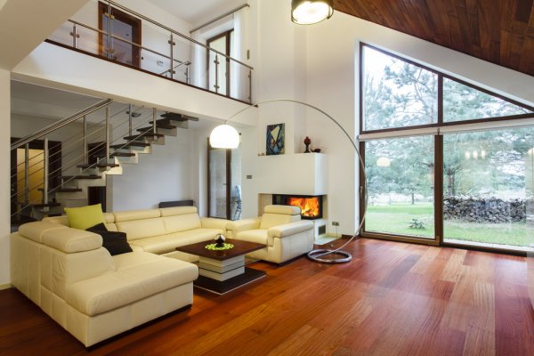
I live in a house. I like my house very much. It’s neither big nor little. When you enter the house you see a big living room. There is a sofa and a table in the middle of the living room. There is a big TV-set on the wall. My living room is light as there are 4 big windows. There is a kitchen to the right and stairs to the upper floor. The kitchen is big, and the whole family can get together for dinner there. My parents also like to invite their friends for dinner.
My room is upstairs. It’s big, with high ceilings. There is not much furniture there, only my bed, my wardrobe and a couple of shelves.
There is a yard around the house. My granny likes to grow flowers there. My dad made a small sports ground with a horizontal bar and a punch bag. There is a swing opposite the sports ground.
There is a garage for our car and my dad’s tools. We also keep our bikes there.

Task 2. Translate the sentences into English using vocabulary words:
Мой папа сделал небольшую спортивную площадку (sports ground) с турником (horizontal bar) и боксерской грушей (punch bag). Напротив спортивной площадки есть качели (swing).
Task 3. Read the text and draw a picture according to the text:
I live in a house. Our house is big. There are two floors in it. There are six rooms in our house. There is a living room, two bedrooms and a big hall on the ground floor. There are children’s rooms and my father’s study on the first floor. My room is on the first floor. I have two big windows in my room. It is big and light. In my room I have a bed, a desk, a chair and two bookshelves
Unit 2 DESCRIBING PEOPLE.

Task 1. Read the text and complete the drawing according to the text:
Susan is a short girl. She is thin. She has got long dark hair and a round face. Her eyes are blue and her nose is turned up. She looks pretty.
She has a brother. His name is John. John is a tall boy. He has got short fair hair and an oval face. His eyes are big and brown. He has big ears and his face looks funny.

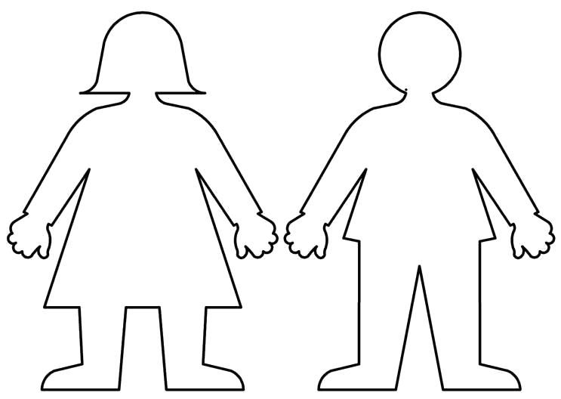

Task 2. Read the text and write your own story about your mother:
My mum is 34 years old. She is very nice. My mum is small and slim. She has got blue eyes and short hair. Her hair is gorgeous. Her fair curly hair always shines bright. She has round face and plump cheeks. Her lips are thin, but her smile is so kind and beautiful.
Her favorite clothes are skirts, blouses, and dresses. Her favorite colors are green and yellow. Her favorite food is salad and all kinds of vegetables.
Her favorite animal is fish. She loves walking in the forest, but she hates skiing. Her hobbies are shopping and cooking. She can cook very well, and she always cleans the house. My mum always says to me that I should be a good pupil.
I love my mum because she is very nice.

Task 3. Read again and answer the questions:

- How old is she?
- What does she look like?
- What colour is her hair?
- What are her favorite clothes?
- What is her favorite colour?
- What is her favorite food?
- What is her favorite animal?
- What is her hobby?
Unit 3 TRUE FRIENDS.

Task 1. Read the text and fill in: friend, important, help, situation, girl, time, sport, true.
My Friend.
I have a very good (1) .... Her name is Mary. Friends are very (2) … in our life. My friend and I always do our best to (3) … each other. We discuss all our troubles and try to find the best decision in any (4) …. My friend is a very good, kind and clever (5) …. We always spend our free (6) … together.
When we have some free time, we go for walks, read and discuss books, watch films, play computer games. Reading is our hobby. We are fond of (7) …. We often go to the swimming pool together. I think she is a (8) …friend.

Task 2. Answer the questions:
- Are friends important in our life or not?
- What do they find in any situation?
- Do they always spend their free time together?
- What do they do when they have free time?
- Do they often go to the swimming pool together?

Task 3. Match the words with definitions:

- Friend - | - generous, helpful, and thinking about other people's feelings
- Important - | - having or showing the ability to learn and understand things quickly and easily
- Kind - | - with each other
- Clever - | - a person you know well and like
- Together - | - necessary or of great value

Unit 4 WORLD OF WORK.

Task 1. Read the text and write out the words of the profession:
Choosing a profession is very difficult. Your choice should depend on your character, intellect, abilities and talent. Do you think someone can be a good teacher if he/she doesn’t love children? Do you think someone can be a good vet if he/ she doesn’t like animals? Can a musician or singer make a success if they don’t have a good ear for music? Can an actor or dancer become famous if they have no special talent? You can never be a respectable judge if you are not just and honest. Only those who are brave, can become sailors. Only people who have creative minds can be successful businessmen. The profession of a doctor requires special education and long training. A doctor must be very responsible because they deal with the most precious thing that people have — their health.
There are a lot of interesting and noble professions, and many roads are opened before you. But remember most professions are available only to educated people. So if you want to be a professional you have to enter an institute or university. It is difficult and you have to study hard. It is not easy, because only those who have a strong will, can study hard. Try to build your character, develop the strength of will and your dreams will come true.

Task 2. Decide, are the sentences true (T) or false (F)?

- Your choice should depend on your character, intellect, abilities and talent. _____
- The profession of a postman requires special education and long training. _____
- Only those who are brave, can become sailors. _____
- If you want to be a professional, you have to enter the university. _____
- Most professions are available only to educated people. _____

Task 3. Find and circle the words in the crossword according to the pictures:
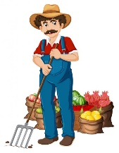

q | q | v | q | q | d | q | q | q | q | q
q | q | e | q | q | o | q | q | q | q | q
q | q | t | e | a | c | h | e | r | q | q
q | q | e | q | q | t | p | q | e | q | q
q | n | r | q | q | o | o | q | s | q | q
w | a | i | t | e | r | s | q | s | q | q
q | m | n | r | q | q | t | q | e | q | q
q | e | a | e | q | q | m | q | r | q | q
q | c | r | m | q | q | a | q | d | q | q
q | i | i | r | q | q | n | u | r | s | e
q | l | a | a | q | q | q | q | i | q | q
q | o | n | f | i | r | e | m | a | n | q
q | p | q | q | q | q | q | q | h | q | q

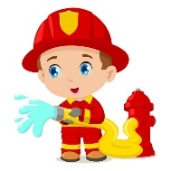
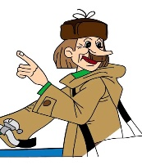

Unit 5 FAMOUSE PEOPLE IN THE UK.

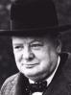
Task 1. What do you know about the people in the pictures?
Sir Winston Churchill

Winston Churchill was a politician, a soldier, an artist, and the 20th century’s most famous and celebrated Prime Minister.

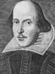
William Shakespeare
William Shakespeare was a playwright and poet whose body of works is considered the greatest in English literature. He wrote dozens of plays which continue to dominate world theater 400 years later.

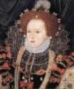
Queen Elizabeth I
The daughter of King Henry VIII and Anne Boleyn, Queen Elizabeth 1 reigned England from 1558–1603. Her reign was marked by several plots to overthrow her, the execution of Mary Queen of Scots (1587), the defeat of the Spanish Armada (1588), and domestic prosperity and literary achievement.

Margaret Thatcher, Baroness Thatcher
Margaret Thatcher was the United Kingdom's first woman prime minister, and she held the office of PM for longer than anyone in the 20th century.

Task 2. Find the second part of the name. Say what these people are famous for:

- Charles  - Margaret  - John R.R.  - Joseph  - William  - Daniel  - Agatha  - Charlie | - Chaplin  - Christie  - Shakespeare  - Defoe  - Darwin  - Thatcher  - Tolkien  - Turner

Task 3. What do you know about Charlie Chaplin? Would you like to know some more information about Charlie Chaplin? Ask a question to the word in bold.
Charlie Chaplin.

- Charlie Chaplin was born on the 16th of April in 1889 in Switzerland.
- In 1913 he moved to the USA.
- He made his first film in 1914.
- The film was called “Making a Living”.
- In his career Chaplin won two Oscars.
- Charlie Chaplin was married four times and had ten children.
- In 1952 he moved to London.
- He died on the 25th of December in 1977.

Unit 6 READING FOR PLEASURE.

Task 1. Read the fairy-tale and do the next tasks:

- Find the verbs in Past Simple in regular forms. Don’t use the same verb twice.
- Find the verbs in Past Simple in irregular forms and give the translation.

Lazy Jack
Once upon a time there was a boy whose name was Jack, and he lived with his mother on a common. They were very poor, and the old woman got her living by spinning, but Jack was so lazy that he would do nothing but bask in the sun in the hot weather, and sit by the corner of the hearth in the winter-time. So they called him Lazy Jack. His mother could not get him to do anything for her, and at last told him, one Monday, that if he did not begin to work for his porridge she would turn him out to get his living as he could. This roused Jack, and he went out and hired himself for the next day to a neighboring farmer for a penny; but as he was coming home, never having had any money before, he lost it in passing over a brook. "Stupid boy," said his mother, "you should have put it in your pocket." "I'll do so another time," replied Jack. On Wednesday, Jack went out again and hired himself to a cow-keeper, who gave him a jar of milk for his day's work. Jack took the jar and put it into the large pocket of his jacket, spilling it all, long before he got home. "Dear me!" said the old woman; "you should have carried it on your head." "I'll do so another time," said Jack. So on Thursday, Jack hired himself again to a farmer, who agreed to give him a cream cheese for his services. In the evening Jack took the cheese, and went home with it on his head. By the time he got home the cheese was all spoilt, part of it being lost, and part matted with his hair. "Stupid lout," said his mother, "you should have carried it very carefully in your hands." "I'll do so another time," replied Jack. On Friday, Lazy Jack again went out, and hired himself to a baker, who would give him nothing for his work but a large tom-cat. Jack took the cat, and began carrying it very carefully in his hands, but in a short time pussy scratched him so much that he was compelled to let it go. When he got home, his mother said to him, "Silly fellow, you should have tied it with a string, and dragged it along after you." "I'll do so another time," said Jack. So on Saturday, Jack hired himself to a butcher, who rewarded him by the handsome present of a shoulder of mutton. Jack took the mutton, tied it to a string, and trailed it along after him in the dirt, so that by the time he had got home the meat was completely spoilt. His mother was this time quite out of patience with him, for the next day was Sunday, and she was obliged to make do with cabbage for her dinner. "You ninney-hammer," said she to her son; "you should have carried it on your shoulder." "I'll do so another time," replied Jack. On the next Monday, Lazy Jack went once more, and hired himself to a cattle-keeper, who gave him a donkey for his trouble. Jack found it hard to hoist the donkey on his shoulders, but at last he did it, and began walking slowly home with his prize. Now it happened that in the course of his journey there lived a rich man with his only daughter, a beautiful girl, but deaf and dumb. Now she had never laughed in her life, and the doctors said she would never speak till somebody made her laugh. This young lady happened to be looking out of the window when Jack was passing with the donkey on his shoulders, with the legs sticking up in the air, and the sight was so comical and strange that she burst out into a great fit of laughter, and immediately recovered her speech and hearing. Her father was overjoyed, and fulfilled his promise by marrying her to Lazy Jack, who was thus made a rich gentleman. They lived in a large house, and Jack's mother lived with them in great happiness until she died.
Task 2. Answer the questions:

- Who are the main characters of the story?
- Why did people call Jack lazy?
- Was his mother happy that Jack didn’t want to work?
- What things did Jack get for his job?
- Did he bring them home?
- What happened in the end?

Task 3. Put the sentences in the correct order:

- He got different things for his work.
- The boy was very lazy.
- Once upon a time there was a boy who lived with his mother.
- But every time he brought these things home in a stupid way.
- So one day his mother grew very angry and wanted him to find the job.
- So Jack became a rich man.
- In the end he carried a donkey on his shoulders.
- Jack went to the farmer to ask for a job.
- This made the daughter of a rich man laugh at him.
- Her father wanted Jack to marry her.
- And they lived in a great happiness.

Unit 7 WHY SHOULD WE LOVE ANIMALS?

Task 1. Read the text and translate into your native language:

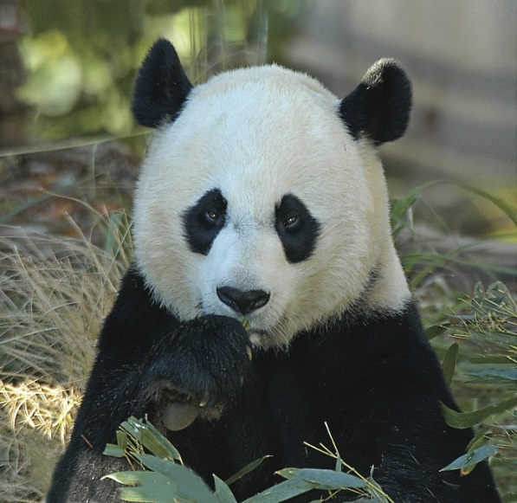
GIANT PANDAS
The giant panda has a huge appetite for bamboo. Pandas will sometimes eat birds or rodents as well. Wild pandas live only in remote, mountainous regions in central China. These high bamboo forests are cool and wet—just as pandas like it. Giant pandas like to live alone. They have a highly developed sense of smell. There are only about 1,000 giant pandas left in the wild. Perhaps 100 pandas live in zoos, where they are always among the most popular attractions. Much of what we know about pandas comes from the study of these zoo animals, because there are so few of their wild cousins.

LEOPARD
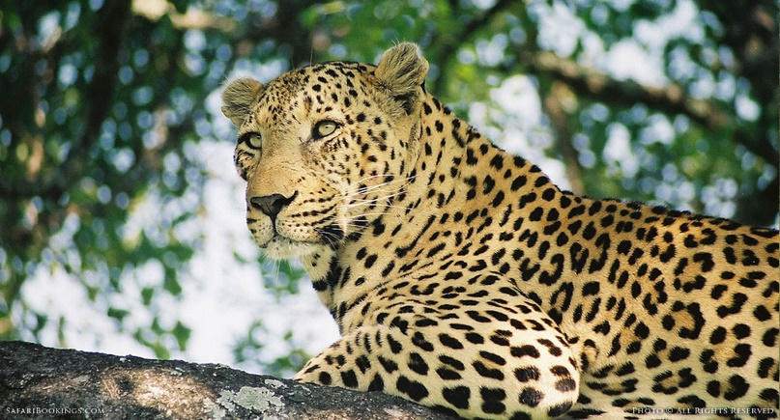
Leopards are graceful and powerful big cats closely related to lions, tigers, and jaguars. The leopard is so strong and comfortable in trees that it often pulls what its kills up into the trees. Leopards can also hunt from trees, where their spotted coats look like leaves. They hunt at night and go after other animals like antelope, deer, and pigs, hiding and walking slowly and silently in tall grass. When human settlements are present, leopards often attack dogs and, occasionally, people. Leopards are strong swimmers and happy in water, where they sometimes eat fish or crabs. They live in Africa, Asia, India and China.

Task 2. Complete the table. Describe PANDA and LEOPARD. Write at least 6-7 sentences.
ANIMAL
SIZE
COLOUR
EAT
LIVES
INTERESTING FACTS

Task 3. Write the report on the topic “WHY WE SHOULD LOVE ANIMALS?”

Unit 8 SPORT.

Task 1. Read the text and translate into your native language:
Sport plays a big role in our life. Many people do sport in our country. They want to stay healthy. Sport is a good mean of struggling with stress.
In my opinion sport is important for healthy free time. Sport also makes people strong and prepares a lot of joy.
Some people participate in sports, others prefer watching them on TV. It is known that walking for an hour is healthier than irregular participation in any active physical activities. To keep fit some people join special classes or take part in aerobics or yoga, do some kind of training in a gym. Others play football, badminton, volleyball, tennis.

Task 2. Complete the sentences with the correct form of PLAY, GO or DO:
- My sister likes to ___volleyball after school.
- Thomas usually ___ horse riding on Saturday mornings.
- My cousin likes to ____ boxing to keep fit.
- It's fun to ____ ping pong.
- Dad ___ archery at the country Club.
Task 3. Fill the crossword: 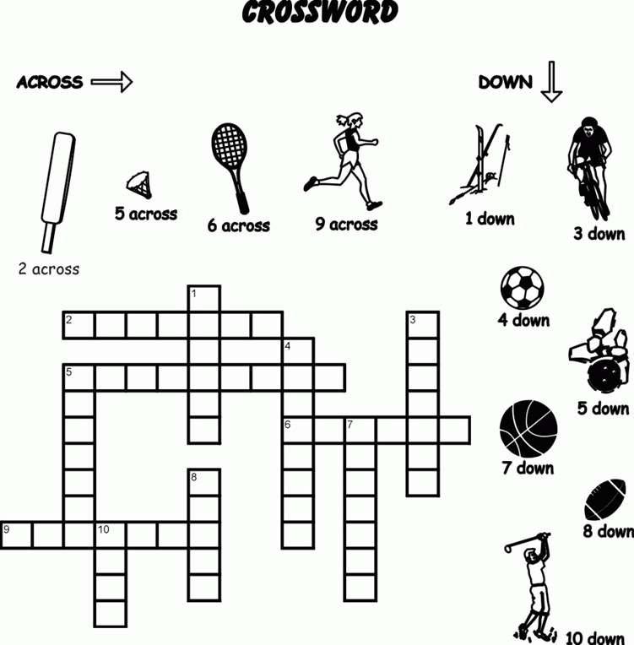
Unit 9 HOLIDAYS.

Task 1. Read the text first.

Holidays.
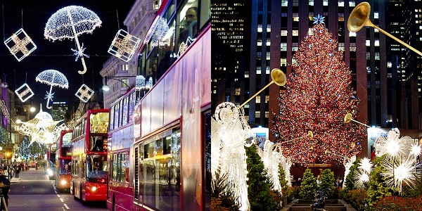
There are eight public holidays (bank holidays) a year in Great Britain, that is days on which people do not need to go to work. They are: Christmas Day, Boxing Day, New Year's Day, Good Friday, Easter Monday, May Day, Spring Holiday and Late Summer Holiday. The term "bank holiday" dates back to the 19th century when in 1871 and 1875 most of these days were constituted bank holidays, that is, days on which banks were to be closed. The observance of these days is no longer limited to banks. All the public holidays, except Christmas Day and Boxing Day observed on the 25th and 26th of December respectively, do not fall on the same date each year. Good Friday and Easter Monday depend on Easter Sunday which falls on the first Monday in May. The Spring Holiday falls on the last Monday of May, while Late Summer Holiday falls on the last Monday in August. Most of these holidays are of religious origin, though for the greater part of the population they have lost their religious significance and are simply days on which people relax, eat, drink and make merry. Certain customs and traditions are associated with most public holidays. The reason is that many of them are part of holiday seasons as Easter and Christmas holiday seasons which are religious by origin and are connected by centuries-old traditions. Besides public holidays, there are other festivals, anniversaries and simply days, on which certain traditions are observed, but unless they fall on a Sunday, they are ordinary working days.
Are the following statements true or false?
- There are six public holidays (bank holidays) a year in America, that is days on which people must go to work.
- They are: Christmas Day, Boxing Day, New Year's Day, Good Friday, Easter Monday, May Day, Spring Holiday and Late Summer Holiday.
- The term "bank holiday" dates back to the 20th century when in 1671 and 1678 most of these days were constituted bank holidays, that is , days on which banks were open .
- All the public holidays, except Good Friday and Boxing Day observed on the 25th and 26th of December respectively, do not fall on the same date each year .
- Good Friday and Easter Monday depend on Easter Sunday which falls on the second Monday in May.
- The Spring Holiday falls on the last Wednesday of May, while Late Summer Holiday falls on the last Monday in August
- All holidays are of religious origin, though for the greater part of the population they have lost their religious significance and are simply days on which people relax, eat, drink and make merry

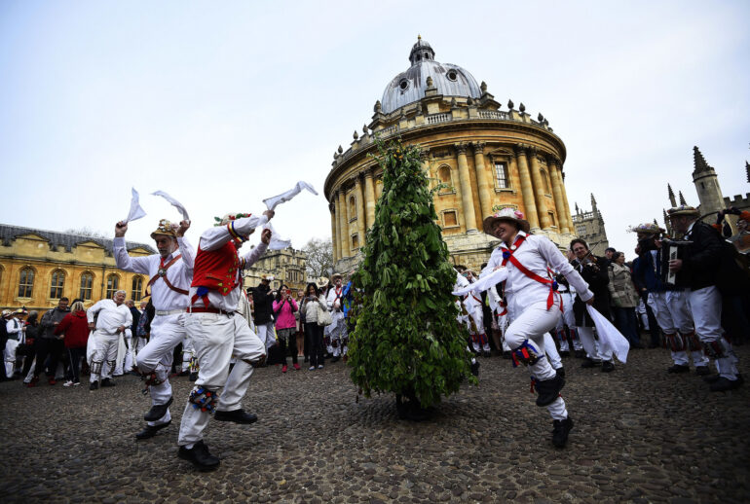

Task 2. Make sentences from these words so that they match the sentences in the text.
- The, all except, public, Christmas , holidays, day ,Boxing ,and, day, On, observed, 25th, the, 26th, December, of, do, respectively, not, on, fall, same, the , each, date ,year, on;
- These, most, of, are, of, origin, holidays, religious, for, the, though, part, greater ,the, of, they, lost, population, have, religious, their, significance, and, simply, are, on, days, people, relax, which, and, drink, eat, and, merry, make;
- holidays, traditions, certain, most, with, customs, are, public, associated, and.
Task 3. Write an essay about the holiday you celebrate in your country.

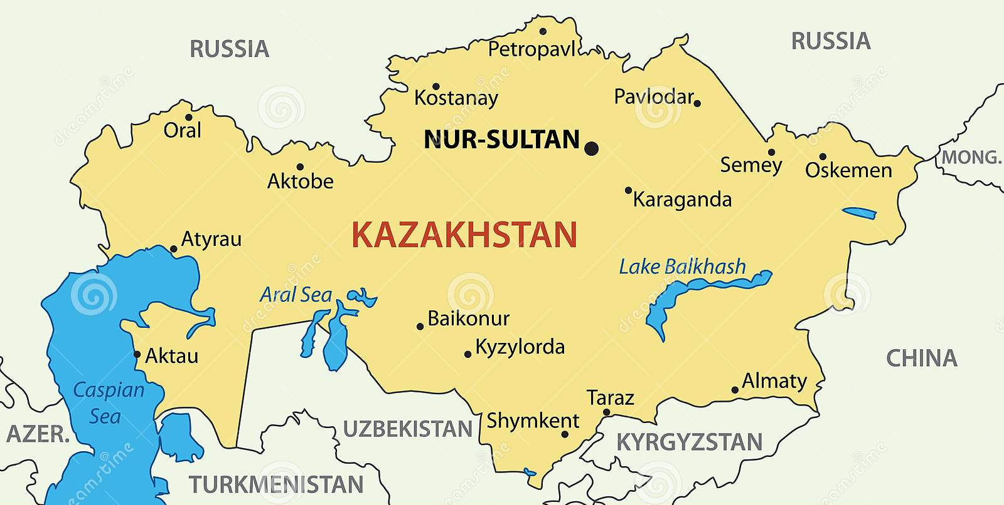
6th grade

Unit 1 OUR CLASS

Task1. Read the text and try to explain the meaning of the words in italic.

First Kazakh Education

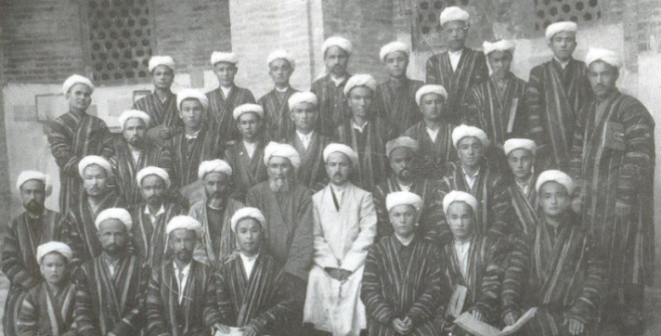
Kazakh people have always honored education. Parents have always formed in their children the desire for knowledge.
For example, there was widely used a proverb "The educated will win a thousand, and the strong – only one".
Almost until the mid-nineteenth century, the teaching of Kazakh children was only in mektebs and madrasa, which gave the Muslim education. Muslim mektebs were mostly attended by boys. They all wore shapans. The training period was from 3 to 4 years. In addition to the knowledge of Islam, students of the madrasa received knowledge in philosophy, chemistry, mathematics, medicine, history, geography, linguistics and astronomy. The madrasa had several classrooms, rooms for students to live in, and canteens. Only people of mature age could be teachers.
In 1912, there were 9 male and female mektebs. Girls and boys were taught separately. The first new-fashioned mekteb in Kazakhstan appeared in Turkestan in 1900.

Task2. Read the text again and answer the questions.

- Where did Kazakh children learn?
- Who can attend those mektebs and madrasas?
- What did they wear?
- What subjects did they learn?
- How many schools were there in 1912?

Task3. Read the text again and mark the sentences T (true) or F (false).
- The text is about modern education. ___
- Kazakh people have never honored education. ___
- They studied in mektebs and madrasa. ___
- Muslim mektebs were attended by boys. ___
- The training period was for 3 years. ___

Task4. Find six names of subjects.
M | E | D | I | C | I | N | E | T | W
A | B | F | A | N | T | A | S | Y | P
T | C | H | E | M | I | S | T | R | H
H | D | I | C | O | M | E | D | Y | I
E | G | S | V | B | D | F | H | J | L
M | I | T | A | N | P | S | U | U | O
A | K | O | C | R | Z | D | F | B | S
T | M | R | E | Q | A | E | G | C | O
I | O | Y | G | O | T | V | W | X | P
C | Q | R | I | H | O | R | R | O | H
S | G | E | O | G | R | A | P | H | Y

Task5. Look at the pictures and try to guess to what period and country does it belong? Find some information and write about one of the ancient schools of Rome.
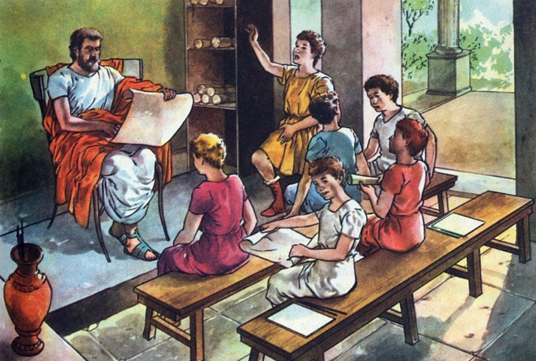

Unit 2 HELPING AND HEROES

Task1. Read the text and put the verbs into the past simple.

Shokan Ualikhanov

His real name is Muhammad-Hanafiya, and all of Kazakhstan today knows and honors him as Shokan Ualikhanov. He .….(be) born in 1835, in the Omsk region, and in modern Kazakhstan it is the Kostanay region. Shokan ……(grow) up in the steppe, but from an early age he was instilled with a love of science. He …….(teach) Kazakh, Arabic and Persian languages, drawing and oriental poetry at the local school. As a cadet in the Siberian Cadet Corps, he mastered French and German, became interested in traveling, and …...(realize) that he wanted to open up the culture of Asia to the whole world. During 12 years of active work, Shokan's personal qualities allowed him to serve in the tsarist army and engage in scientific research and creativity. He …..(leave) his descendants great works that ……(help) to study the culture of people of Central Asia. He was also engaged in the compilation of geographical maps of Central Asia. He improved the system of self-government and implemented judicial reform. In 1961 and in 1972, a five-volume collection of works by Shokan Ualikhanov was published in Russian. He …..(die) in April 1865.

The map of Central Asia by Sh. Ualikhanov

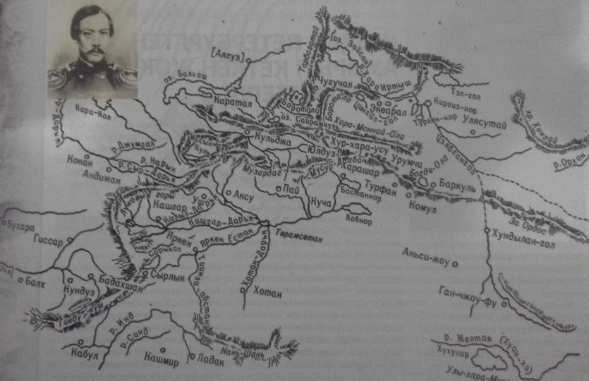

Task2. Read the text again and answer the questions.

- What is the real name of Shokan Ualikhanov?
- Where was Shokan Ualikhanov born?
- How many languages did he know?
- Where was his collection of works published?
- When was it published?

Task3. Read the text again and mark the sentences T (true) or F (false).
- Shokan liked drawing when he was a pupil. ___
- He studied the culture of people of North America. ___
- He studied in the Siberian Cadet Corps. ___
- He didn’t improve the system of self-government. ___
- Shokan made a great contribution to Kazakh people’ culture. ___
Task4. Match the words and use them to complete the sentences.
1 |  | judicial | a | Asia
2 |  | Central | b | maps
3 |  | oriental | c | qualities
4 |  | personal | d | reforms
5 |  | geographical | e | poetry

- Main part of …………… travel is through Uzbekistan
- The head of state told about …………… in Kazakhstan.
- Oriental poems are popular examples of all types of ……………….
- ……………….. are the characteristics of a person.
- The ………………….. is a great educational resource.
Task5. Think of one more hero of your country and write a short essay about him/her. What was he/she famous for?

Unit 3 OUR COUNTRYSIDE

Task1. Read the text about Burabay and match the words.
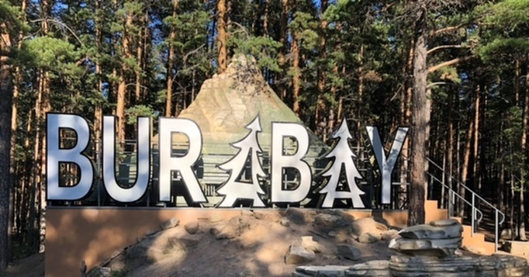
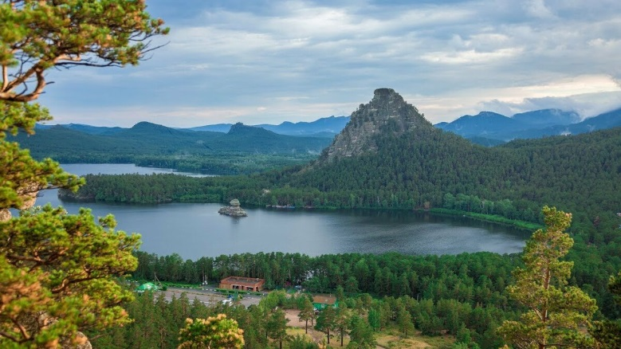

1 |  | mysterious | a | castles and palaces
2 |  | prophetic | b | giants and ghosts
3 |  | grand | c | land
4 |  | fairy | d | heaps
5 |  | fantastical | e | camel

Kazakhstani Switzerland is the second name given to Burabai, Kokshetau region, which is in the Northern Kazakhstan.
It harbors wonders: hillocks overgrown with trees, stony ridges, fantastical heaps of rocks like fairy giants and ghosts as silent as bewitched lakes. This mysterious land is Burabai, also called Borovoe.
"Bura " in Kazakh stands for camel. There is an old legend about prophetic camel, which used to live in Burabai neighborhood.
Its legends, nature impress as some grand castles and palaces. Okzhetpes is the most beautiful crag and Zhumbaktas is a puzzle-stone.
Burabai pine forest is good at any time, in every weather. In winter the pine forest is covered with white snow, in summer – a light wind blows up the aromatic resinous waves, in autumn – the forest smells the peculiar air, a mixture of wet pine rind with mushrooms and herbs. Burabai is a resort, known far beyond Kazakhstan, rich in health centers, which are involved in climatology treatment and treatment by cumus (horse's milk).

Task2. Find six adjectives from the text.
F | A | F | H | J | L | N | P | T | M
A | B | S | E | C | O | N | D | Y | Y
N | C | E | U | Y | L | M | V | K | S
T | D | Z | C | O | M | E | D | Y | T
A | G | W | V | B | D | F | H | J | E
S | A | S | I | L | E | N | T | T | R
T | K | S | C | R | Z | D | F | B | I
I | M | L | I | G | H | T | H | H | O
C | O | E | G | O | T | V | W | X | U
A | Q | R | I | H | O | R | R | O | S
L | S | S | F | A | I | R | Y | H | L

Task3. Read the text again and mark the sentences T (true) or F (false).
- The text is about a resort in Switzerland. ___
- Switzerland is the second name of Burabai. ___
- It is also called Borovoe. ___
- "Bura " in Kazakh stands for horse. ___
- Burabai pine forest is good only in summer. ___

Task4. Answer the questions
- What do you need to make a film?
- How much money does it take to make a good movie?
- Is it necessary to look for top stars?
- Why do you need to invite unknown actors?
- What type of movie would you like to make? Why?

Task5. Make up a short report about similar resorts of your region.

Unit 4 DRAMA AND COMEDY

Task1. Read the text and find synonyms for the words in italic.
How to make a
horror movie

1 | big
2 | frightening
3 | bad
4 | good
5 | cold

First you have to find a really big¹ sum of money – preferably about half a million dollars, but you can make a movie for much less if you try. Then you need someone who can write a good story. The story must keep the audience interested and scared the whole way through. The characters must be believable and the events that take place should be frightening², so that the audience wants to see more and more. If the story’s bad³, then you are not going to have a successful movie, however good⁴ the special effects are.
OK, now you are ready to find some actors. It would be surprising if any top stars accepted your innovation to appear in your first movie, so look for actors who have only had small parts in movies before. They won’t complain when you are all outside in cold⁵ weather, filming a scene for the twentieth time. Don’t give up. You may be tired, but you could be the James Cameron or Wes Craven!

Task3. Read the text again and mark the sentences T (true) or F (false).
- The text is about rules of behaving in the cinemas. ___
- You needn’t much money to make a movie. ___
- To keep the audience scared the story must be romantic. ___
- Special effects are important in making successful movie. ___
- Unknown actors will agree to work in difficult conditions. ___

Task2. Find six names of the types of films.

H | A | F | H | J | L | N | P | T | W
I | B | F | A | N | T | A | S | Y | X
S | C | E | U | Y | L | M | V | K | A
T | D | Z | C | O | M | E | D | Y | D
O | G | W | V | B | D | F | H | J | V
R | I | E | A | N | P | S | U | U | E
I | K | S | C | R | Z | D | F | B | N
C | M | T | E | Q | A | E | G | C | T
A | O | E | G | O | T | V | W | X | U
L | Q | R | I | H | O | R | R | O | R
Q | S | N | J | L | N | M | K | H | E

Task4. Answer the questions
- What do you need to make a film?
- How much money does it take to make a good movie?
3. Is it necessary to look for top stars?
4. Why do you need to invite unknown actors?
5. What type of movie would you like to make? Why?

Task5. Write about one of your favorite movies.

Unit 5 OUR HEALTH

Task1. Read the text and fill in: healthy, sport, organic, vegetables, centers, life – style.

Healthy life style.

Nowadays ….. life-style is gaining more and more popularity. Lately people have finally realized that whatever a person would do and whatever post he would hold, health is the most valuable wealth in our life.
People became more health-conscious. Even developing countries began to take GMO, colorings and unnatural additives with caution. Now buying only …….. and healthy food, eating more fruits and …... as well as going in for sports and keeping fit are in.
…... is as important as the quality of food. Many people are still lazy and do not want to take up any sports, because they think that sport is only weights and bulky exercise equipment. In fact, sport is an active approach to life and desire to improve a body. We are not talking only about the gyms and professional sports ………. The alternative of any exercises can be dancing, walking and jogging in the open air.
Healthy …….. is not only a sound body but also a sound mind. Faith, optimistic approach to life, ability to keep even temper and calm - these things are also equally important.
Task2. Read the text again and mark the sentences T (true) or F (false).
- The text is about being healthy. ___
- Healthy life – style is not so popular now. ___
- People became take food with caution. ___
- Sport is desire to improve our body. ___
- Dancing can’t be the alternative of exercises. ___

Task3. Match the words and use them to complete the sentences.
1 |  | valuable | a | countries
2 |  | developing | b | sport
3 |  | lazy | c | wealth
4 |  | professional | d | air
5 |  | open | e | people

- You must lead a healthy lifestyle to succeed in...………….
- Running in the ………….. is good for our lungs.
- The health of our children and parents is the most …………
- ……………… can only complain about their health.
- People living in ……………………. know everything about a healthy lifestyle.

Task4. Answer the questions.
- What is the text about?
- What do people do in order to keep fit?
- Do lazy people succeed in keeping fit and being healthy?
- What can be the alternative of any exercises?
- What things are also important in healthy life – style?

Task5. Make a list of healthy habits.

Unit 6 TRAVEL AND HOLIDAY

Task1. Complete the sentences with the following words: number, countries, different, mountains, travelling, way.

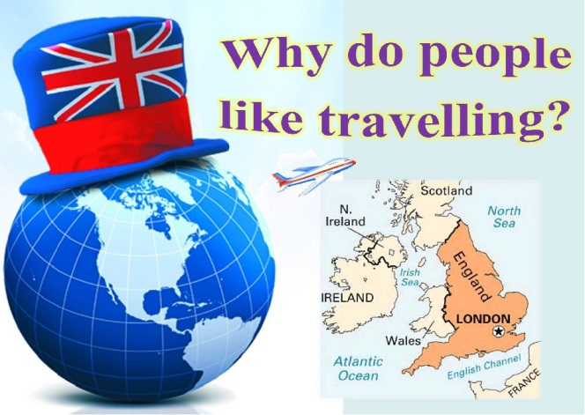
A huge ___________ of people all over the world spend their free time travelling.
There are a lot of reasons why people travel. Some of them go abroad because of business trip, others because they want to see new ____________ and continents, to learn a lot about peoples traditions or to enjoy picturesque places and the ruins of ancient cities. It's always interesting to discover new things, different ways of life, to meet ____________ people, to try different food and to listen to foreign music.
City – dwellers usually like a quite holidays by the sea or in the ____________ with nothing to do but walk and bathe and laze in the sun.
Now, more and more people have an opportunity to travel abroad. New impressions, thrilling adventures have always delighted both – children and grown –ups.
There are a lot of means of traveling: by sea, by plane, by car or on foot. Tastes differ. That's why it's up to you to decide which means of ____________ you would prefer.
Travelling is the best way to learn geography and the best _____________ to get knowledge about our planet, to meet interesting people and to learn others countries.
Task2. Read the text again and mark the sentences T (true) or F (false).
- The text is about different food and foreign music. ___
- There are not many reasons for people to travel. ___
- Travelling is the best way to learn geography. ___
- City-dwellers usually don’t like a quite holidays. ___
- There are a lot of means of traveling. ___

Task3. Match the words and make up sentences with them.
1 |  | huge | a | impressions
2 |  | new | b | trip
3 |  | thrilling | c | number
4 |  | business | d | music
5 |  | foreign | e | adventures

Task4. Answer the questions.
- What are the reasons to travel?
- What do usually city-dwellers like?
- What are the means of travelling?
- Which means of travelling do you prefer?
- What reasons for travelling can you add?

Task5. Look at the picture and write a short essay. Where and how would you go?

Unit 7 READING FOR PLEASURE

Task1. Read the text and retell.
The Magic Basket
A mother and her little son live in a little house. They are very poor. All they have is a grey goat.
One day the mother says, “We have got no money, we have got no bread. You should go and sell the goat”. The boy takes the goat and goes to the town. He meets a farmer with a large basket in his hands. “Sell me your goat”, says the farmer.
“What can you give me for it?” asks the boy.
“I can give you this basket”, says the farmer.
“What good is this basket for me?” says the boy. “What can I put in it? I’ve got no bread, I’ve got no eggs and I’ve got no apples!”
“My little girl is ill”, says the farmer. “She must drink some milk from a grey goat every day or she will die”.
The boy is kind. He is sorry for the little girl. He gives his goat to the farmer, takes the basket and goes home.
When he comes home, he puts the basket on the table and shows it to his mother.
The mother looks at the basket and says, “What good is this basket for us, what can we put in it?”
But suddenly the basket says, “I’m a magic basket!” The basket jumps from the table and runs out of the house. When it comes back to the poor boy’s house, it is full of meat, fruit and vegetables. Now the mother and the boy have dinner.
Every morning the wonderful basket jumps from the table and runs out of the house. And every day it comes back full of good things. Now the mother
and her son have their breakfast, dinner and supper every day.
Task2. Put the events in the correct order.
The boy takes the goat and goes to the town.
He puts the basket on the table and shows it to his mother
They live in a little house.
The basket says, “I’m a magic basket!”
Every day it comes back full of good things.
The boy meets a farmer with a large basket in his hands.

Task3. Read the text again and mark the sentences T (true) or F (false).

- The text is about rich boy and his mother. ___
- They were rich and had five white goats. ___
- The boy takes the goat and goes to the town. ___
- Every morning the wonderful basket jumps from the book. ___
- And every day it comes back empty. ___

Task4. Answer the questions
- Do you like the tale? Why?
- Do you like reading?
- What genres do you like to read?
- Who is your favorite writer?
- What is your attitude towards Ben? How do think what kind of person he is?

Task5. Write about a favorite book or fairy tale from your childhood.

Unit 8 OUR NEIGHBORHOOD

Task1. Look at the picture and read the title. Guess what is the text about? Read and check.
Ben lives in Oxford, a famous town in England. He thinks life in the city is fantastic. There are always places to visit and lots of things to do. Ben likes visiting museums and going to the cinema or to the theatre. He loves eating out too. He is crazy about Mexican food and often goes to a Mexican restaurant with his parents. Sometimes Ben meets with his friends and they like eating burgers together. One thing he doesn’t like about the city is the traffic. There lots of cars and buses in Oxford and sometimes it is difficult to move around in the streets.
Ben’s best friend Susan lives in a village near Oxford. She likes living in the country because there is no traffic and people can work outdoors. There air is healthy because there are a lot of trees around. Susan likes to go to the forest and to the river, which is not far from her place. She likes swimming and bathing in the river. She likes listening songs of birds in the mornings and looking at stars at night. She thinks it is very beautiful.
When they visit each other, they talk about things they did and share their opinions about city life and country life. It is always fun to listen to them because they never stop talking about advantages of living there.

Task3. Read the text again and mark the sentences T (true) or F (false).
- The text is about Ben and his family. ___
- Susan likes going to the cinema with her friends. ___
- Ben likes Italian food. ___
- Country life is very noisy and busy. ___
- Susan thinks that night stars are beautiful. ___
Task4. Complete the table with advantages and disadvantages of living in a city or a country.

Task5. Give full answers to the following questions.
- What do Ben and Susan argue about?
- Do you live in the city or in the country?
- Do you like life in your place? Why/Why not?
- What city or country would you like to live in?
- Write about places to go in your city/country?

Unit 9 TRANSPORT

Task1. Read the text and answer the questions.
My name is Teresa Cash and I live in Bowling Green, Kentucky. About seventeen years ago, I became a transport driver and I drive homeless pets wherever they need to go, to Maryland, Pennsylvania, New Jersey and New York City. These pets go to rescue groups who sponsor them and then adopt them out to new families. There is a site called “Petfinder.com”. People looking for pets can go to that site and can see animals. On our very first transport, we took ten dogs to Maryland in the back of a little Nissan pickup truck. After that I drove different transport, such as cargo vans, big trucks, bicycles, Lorries, cars, motorbikes and so on. We move 2500-3000 animals per year. We love saving lives and that is always our goal. Over the years, I’ve moved dogs, cats, bunnies, guinea pigs, hamsters, mice, gerbils, degus, birds, ferrets and even the occasional pot-bellied pig. I drive in all kinds of weather ... rain, snow, sleet, tornados. I even drove with a hurricane coming one time. I meet interesting people and find myself in crazy situations at times. I've written this story to share my adventures, stories, heartbreak, happiness....

- What was Teresa’s first transport?
- Whom did she help?
Unit 9
- What is her goal?
- Do you like her job? Why?
- Do you help animals? How?

Task3. Read the text again and mark the sentences T (true) or F (false).

- The text is about Teresa from New Jersey. ___
- She became a transport driver for homeless people. ___
- Teresa moved 2500-3000 animals per year. ___
- She doesn’t afraid of tornado. ___
- She likes her job very much. ___

Task2. Find six names of the transport from the puzzle.

W | A | F | H | J | L | N | P | T | B
C | B | L | O | R | R | I | E | S | I
A | C | E | U | Y | L | M | V | K | G
R | D | Z | C | A | R | S | D | Y | T
G | G | W | V | B | D | F | H | J | R
O | A | S | I | L | E | N | T | T | U
V | K | S | C | R | Z | D | F | B | C
A | M | L | I | G | H | T | H | H | K
N | O | B | I | C | Y | C | L | E | S
S | A | D | F | T | R | E | J | H | O
M | O | T | O | R | B | I | K | E | S

Task4. Match the words make up sentences with them.
1 |  | homeless | a | situations
2 |  | rescue | b | vans
3 |  | interesting | c | groups
4 |  | crazy | d | people
5 |  | cargo | e | pets

Task5. How do you think which transport is safer? Write your opinion.

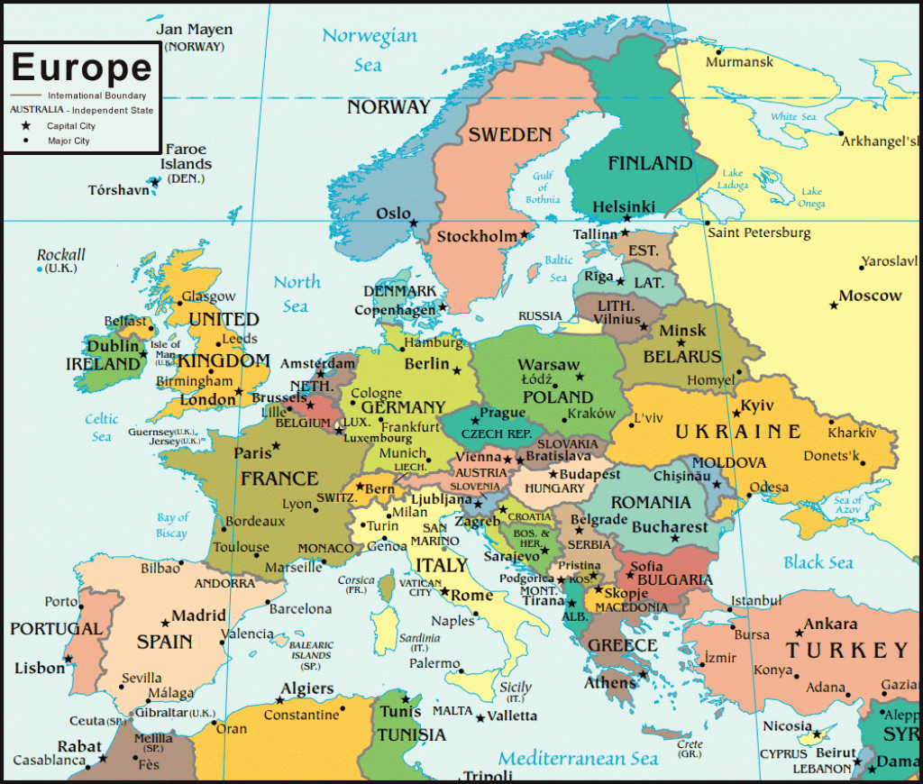
7th grade

Unit 1 HOBBIES AND LEISURE

Hello! My name is Johnny. I’m thirteen years old and I live in England. I just want to talk about how my friends and I spend our free time.
My best friends are Tom and David. They are in the same class as me. Teenagers often complain they’re bored and have nothing to do. I can’t understand them. I’m never bored.
If the weather is nice we go for a walk we ride our bikes. All of us love rollerblading. We often play football, basketball or Frisbee in the park and when it is rainy we go to the sports center. Here we usually play table tennis or go swimming. If you play a musical instrument it’s a good fun! I play the guitar and practice a lot.
At home I usually listen to music or read magazines and books. Of course as other teenagers I often go on the Internet or play computer games - but not always! It’s a pity that a lot of teenagers live their lives on several public sites like Facebook or Twitter! They had better make real friends!
In the evening I sometimes watch TV. I often invite my friends over for dinner or a cup of tea and we play chess or cards.
At the weekend we go hiking, fishing or sometimes we go to the cinema. We like comedies
Task1. Read the text are the statements true (+), false (-) or doesn’t say?
- Johnny has a lot of friends.
- He is often bored
- He and his friends like doing sports.
- At home he helps a lot.
- He plays a musical instrument.
- He likes listening rock music.
- He is addicted to the internet.
- He has a Facebook profile.
- In the evenings he’s usually at home.
- He never goes out at the weekends.

Task2. Answer the questions.
1 What do Johnny and his friend do outside?
2 When do they go to the sports Centre?
3 What’s his opinion about teens that are addicted to the Internet?
4 Who does he invite in the evenings?
5 What kind of films does he like?
Task3. Match the pictures to the words
Task 4 Complete the sentences.

1. Teenagers often ______ they’re bored.
2. Lots of them live their lives on _____ sites.
3. It is _____ to make real friends.
4. You can _________ your free time interestingly if you want.
5. You can ________ a lot of things in your free time.

Task5. Answer the questions about your hobbies.

What about you?
What do you usually do in your free time?
Who do you spend your free time with?
Do you have a lot of friends?

Unit 2 COMMUNICATION AND TECHNOLOGY

MY MOBILE PHONE
Task1. Read the text
Hello I’m Kate. I want to write about my mobile phone. I got it from my parents for my birthday two years ago. I like it very much and I think it’s sometimes good to have it in my bag. I always keep it in my bag or in my pocket so my parents and my friends can always telephone me.
It’s got a calculator in it so I sometimes use it at school. It’s also a kind of information file. I can use my mobile phone to connect to the Internet and look through the news or read emails on my computer. Isn’t it fantastic?
Last year I was on a cycling holiday with my friends. We went cycling but the weather wasn’t good. It was cold and windy. It started to rain and it got dark. Suddenly my friend fell of her bike and she broke her leg. At first I didn’t know what to do but then I thought about my phone. It was in my rucksack so I telephoned for help. After fifteen minutes a doctor arrived.
Sometimes people are not keen a mobile phones. They are a real problem because they always ring at the wrong moment. I’m not crazy about my phone but I feel safe when I have it with me.

Task2. Are the statements True, False or doesn’t say?

1. Kate can’t exist without her mobile phone.
2. She got her mobile in January.
3. Her parents bought her the mobile phone one year ago.
4. There’s a calculator in her mobile.
5. She can connect to the Internet with her mobile.
6. She usually listens to music on her mobile.
7. She can’t read emails on her mobile.
8. There are often a lot of problems with mobile phones.
9. Kate always takes on her mobile to her friends.
10. She doesn’t like the mobile phones.

Task3. Answer the questions.
1. Where does Kate keep her mobile?
2. What can she use it for?
3. When was she on a cycling holiday?
4. What happened there?
5. How did Kate solve the problem?

Task4. Complete the sentences.

- Kate‘s parents and friends can always ______her.
- Her mobile phone is also a kind of ____________.
- On the cycling holiday after the accident Kate phoned for _________.
- Mobile phones often _______ at the wrong moment.
- Children can feel _______ when they have their mobile phones with them.
Task5. Match pictures to the words.

Calculator /mobile phone / laptop, MP3 player / radio / computer / scanner /karaoke set / CD player / play station / television / camcorder / DVD player / USB pen / camera

Unit 3 HOLIDAYS AND TRAVEL

GOING ON HOLIDAYS

Before travelling

I usually have to prepare a lot before travelling .First, I check if my formal documents are valid. I usually look for nice accommodation facilities in the country where I would like to travel. I book a double room on the Internet. I also check the weather forecast. Then I borrow a guidebook from the library to see what tourist attractions there are in the place where I want to go.
A few days before travelling, I go shopping and buy the necessary products. I exchange some money too. Then I pack my summer clothes (e.g. T-shirts, skirts, shorts, bikinis, a tracksuit, slippers, etc.), Some suntan lotion, toiletries and a camera with me , I also take some medicine in the suitcase. In my handbag, I put all the necessary documents (e.g. a driving license, a passport, an identify card, local currency, travel insurances and a credit card, etc.), of course.
At the airport
There are many people at the airport .They want to go somewhere by airplane. After buying tickets, they check in and wait for the departure of the plane in the departure lounge. The announcer nicely informs important news that all people must know.
My husband and I are going to Corfu to have a great holiday this summer. When we travel, we usually take the car to airport. My husband parks the car in the car park. Then we go to the check – in –desk. At the check – in – desk, the woman looks our passports and air tickets, takes our luggage and gives us our boarding cards. We and our luggage go through a security gate. We look at our boarding cards to see our seat numbers on the plane. On the plane, we look for our seats. Of course, we also listen to the stewardess’s instructions.
At the hotel
On the arrival day, we check in at the reception desk. We fill in a form and give all our personal data. The receptionist tells us our room number and gives us or key. We pay for the room in advance by credit card. In the morning, we have breakfast in a separate room of the hotel. There is usually a big buffer table. So we can taste a lot of food. On the departure day, we checkout the hotel and go the airport by taxi.
At the hotel, there is free Wi-Fi connection, a sauna, a Jacuzzi, a bar and a restaurant too. If I want, I can also ask for a room service. In the morning, the cleaning lady comes and cleans our room.

Task1. Answer the question.

1 How does she prepare for a journey?
2 How can people check- in at the airport?
3 How do the wife and the husband check – in at the hotel?
4 What service can a hotel provide?
5 What is your favorite country and Why?
6 How do like to travel?

Task2. Match the definitions with the bolded words from the text.

1 The opposite of check – in….
2 The synonym of baggage…
3 To reserve a hotel room…
4 Perfume, a toothbrush, shower – gel, a tube of toothpaste…
5 The person who works for a hotel…
6 A person who visit sights….

Task3. Use to pictures and try to write about process of going on holiday.

Task4. Match the words to their meaning.

Tour/ trip / voyage / excursion / travel

- The activity or action of travelling __________
- A long journey , usually by sea or in space ________
- A visit round a place of interest, often with a guide ________
- A journey to a place for a short time (for pleasure or on business) ________
- A journey to a place of interest, often officially organized for a group _______

Task5. Answer the questions about you. (50 words)
Which of the places would you like to visit? Why?

Unit 4 SPACE AND EARTH

Task1. Read the text about The Eight Planets of our Solar System then write name of planets
Distance to sun: about 58 million km
Moons: none Diameter: 4,879 km at the equator
- ________ is the planet in our solar system that is closest to our sun. Named after the Roman god Mercury who was the messenger to the gods, it is the smallest planet, and is very difficult to see because it is so close to the sun.
Distance to sun: about 108 million km
Moons: none Diameter: 12,100 km at the equator
- _______ is sometimes called our “sister planet” because it is nearly the same size as Earth, and it is closest to us. Second from the sun, it is named after the Roman goddess of love. It often appears very bright in the early morning sky.
Distance to sun: about 150 million km
Moons: one Diameter: 12,756 km at the equator
- _______ is the only planet that we know of, so far, that has life. It also has one of the solar system’s largest moons. Three quarters of the planet is covered by oceans. Over 7 billion people live on Earth in about 200 countries.
Distance to sun: about 228 million km
Moons: Two Diameters: 6,792 km at the equator
- _______ is smaller than both Venus and Earth, but has the solar system’s largest volcano. Named after the Roman god f war (because of its blood – red color), many scientists believe that humans will travel to Mars this century.
Distance to sun: about 778 million km
Moons: 60-70 Diameters: 142,984 km at the equator
- _______ is the largest planet in our solar system, and the third brightest object in the night sky. Named after the king of the Roman gods in mythology, Jupiter (along with Saturn, Uranus, and Neptune) is known as a “gas giant”.
Distance to sun: about 1, 4 billion km
Moons: 60-70 Diameters: 120,536 km at the equator
- _______, the sixth planet from the sun, and the second largest planet, is special because of rings (some other planets have them, but ______’s are largest). It is named after the Roman god of agriculture (as is ‘Saturday’).
Distance to sun: about 2, 88 billion km
Moons: 27 (maybe more) Diameter: 51,118 km at the equator
- _______ was only ‘recently’ discovered by Englishman William Herschel in 1781.The planet was first named after King George III of England, but the name was later changed to ‘______’ (after the Greek god of the sky).
Distance to sun: about 4.5 billion km
Moons: 13 (maybe more) Diameter: 49,528 km at the equator
- ______ is the furthest planet from the sun (although small ‘dwarf planets’ such as Pluto are even more distant). Discovered by French and English astronomers in 1846, it is named after the Greek god of the sea.

Task2. Match the words with their meaning.

- Solar system ___ A. how far away something is from another thing
- Distance ___ B. the sun and all its planets
- Diameter ___ C. 1,000.000.000
- Billion ___ D. how far from one side to the other

Task3. Write ‘T’ (True) or ‘F’ (False) next to each statement.

- ____ Earth is our solar system’s largest planet
- ____Uranus is larger than Neptune
- ____ Jupiter is the third planet from the sun
- ____ Mercury has two moons
- ____ Saturn is the only planet that has rings
- ____ Earth is only mostly covered by water
- ____ Neptune was discovered by French and German astronomers in 1846

Task 4. Answer the questions
- How many planets don’t have moon?
- Which planet gave its name to a day of the week?
- Which planet is not named after a Roman or Greek god?
- What is an example of a dwarf planet?
- Which planet has a large moon and oceans?
- Which planet is the smallest?
- Which planet was first named after a person?

Task 5. Discuss:
Imagine you discovered a new planet. What name would you give it ? Why?

Unit 5 READING FOR PLEARSURE

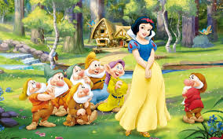 SNOW WHITE AND SEVEN DWARVES
Task1. Complete the correct tense.
A long time ago, child ___ (be) born to a queen and king and she was called Snow White. When the queen ___ (die), the king married again. This new queen was wicked and hated Snow White. The queen ____ (give) orders that Snow White was to be treated as a servant. Snow White grew very beautiful and one day a Prince riding by, saw her at work and fell in love with her. The queen was beautiful too, and every day she ___ (ask) her Magic Mirror, “Who is the fairest in the land?” and the mirror always answered, “You are the fairest one of all”. But one day the mirror ____ (answer) Snow White was the fairest in the land, and in a rage the queen gave orders to one of her huntsman to take Snow White into the woods and kill her. The huntsman had a kind heart and couldn’t do the deed so to run away. She fled into the woods where little dwarves lived. Their house was small land strange. Snow White entered the little house and finding it very untidy, started to clean up. Upstairs, she ___ (find) seven little beds. She was very tired and stretching out on one of the beds, was soon asleep. When the Dwarves___ (come) home they were surprised to find Snow White and after some argument, decided to let her stay. She___ (promise) to cook and look after them. The Queen discovered where Snow White was living and disguising herself as a witch, took a poisoned apple and set out for the Dwarves cottage. She gave Snow white the poisoned apple to eat and as soon as she hit the apple, she sank into unconsciousness. Thinking she was dead, the Dwarves built a glass coffin and put her in it. For days she lay in the forest in her glass coffin. One day, the Prince was riding through the forest looking for Snow White and found her. He leaned over and kissed her. She___ (open) her eyes and sat up with a smile. Everyone was happy. The Prince took Snow White to his palace where they were married and lived happily ever after.
Task2. Write the words that are missing. (Coffin, beautiful, shy, poisoned , knock , hungry, young , waking)
- She is nice and pretty but very ____.
- “Mirror, mirror on the wall, who is the most ____ of us all?”
- It is dark and Snow White is _____ and cold.
- The apple is ________!
- She is now laying in the glass ________.

Task 3. Answer the questions.
- Describe the Snow white?
- Why did Evil Step Mother hate Snow White?
- Where did Snow Whide hide ?
- What did Evil Queen dofor Snow White?
- Use your words and end the story.

Task4. Circle the correct choice.
- Snow White lived in a …….
Small cottage / tall tower / castle
- Her stepmother had a ……. Which always told the truth?
Magic mirror / magic comb / magic table
- The guard took a wild …. Heart to the stepmother.
Deer’s /pigs /goats
- The vicious woman felt ….. When she learned that Snow White was alive.
Shocked /joyful / excited
- The dwarves put her in a ….. Coffin and started to the mountains.
Golden / silver / crystal

Task 5. Writ the words of picture
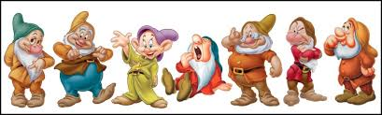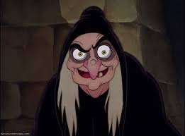
___________________ ___________________ _______________________
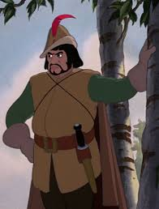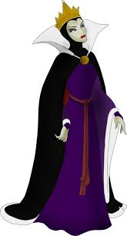
______________ _____________

Unit 6 ENTERTAINMENT AND MEDIA

Sony shows off jogging robot
A small step for a Sony robot could turn out to be a giant leap for “robot kind”. In2003 Sony showed a new version of its QRIO robot that could jog at a top speed of 14 meters per minute.
Running is a much more difficult task for a robot to perform as both of the machine’s feet must be off the floor at the same time .Sony said the QRIO jogging robot was the result of three years of work but that it had no plans to put it on sale like the AIBO robot dog.
QRIO stands for “quest for curiosity”. The robot, which was previously known as the SDR, has earlier been shown walking, climbing, kicking a ball and dancing. Now Sony has updated the robot, which is usually shown off at trade shows and other events, to run slowly for a short distance. If the 58cm high robot were human –sized, it would be able to run at a speed of about 2, km per hour.
QRIO is also able to speak now. Its “voice “is generated using software that converts text to speech. It has on board two digital cameras that help it learn about its surroundings and recognize up to 10 faces.
Sony uses the friendly robot as an ambassador for its products at events. This robot puts Sony ahead of Honda, which has shown off its ASIMO robot that, so far, can only walk.
Sony has enjoyed huge success with its AIBO robot dog and has sold more than 130,000 units of that technological pet. AIBO costs around 69,000 yen, about 520 euros.
But QRIO’s adventures don’t stop here! The robot has made its TV debut: it recorded its voice for a small part in a top Japanese cartoon show called “Astro Boy”. QRIO has clearly impresses Kazuya Konaka, its director. “Our message is that robot is our partners”, he said. “This has demonstrated that robots and human beings can work together”.

Task1. Answer the following questions in your own words as far as possible.

- How fast can the QRIO robot run?
- Why is it so hard for a robot to run?
- What is the main difference between the QRIO and the ASIMO robots?

Task2. What do the underlined words in the text refer to?

- It 2. That 3. It 4. Which 5. its

Task3. True or False? Quote from the text to justify your answers.

- Sony’s QRIO represents a major advance in robotics.
- People can buy the QRIO robot soon.
- The robot’s name means searching, wanting to learn more.
- QRIO is a human-sized robot.
- QRIO is used to present and promote Sony’s technological innovations

Task4. Complete the following according to the text.

- The first version of QRIO, DR, could already….
- Because of its size, QRIO can’t…..
- After having been improved, the QRIO robot can not only run ….
- QRIO’s ability to speak allowed it to play

Task5. Match the words from the text with their equivalents on the right.

1. Shows off a) execute
2. Leap b) first appearance
3. Top c) modernized
4. Perform d) environment
5. Quest e) translates
6. Updated f) achievement
7. Convert g) representative
8. Surroundings h) exhibits
9. Ambassador i) maximum
10. Debut j) search

Unit 7 NATURAL DISASTER

THE ERUPTION OF KRAKATAU

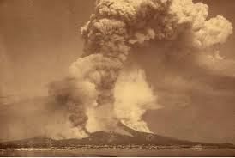The eruption of the Krakatau (or Krakatoa) on a small island located in the middle of the Sunda Strait in August 1883 was in many aspects, the first global catastrophe.
The news about the eruption its following tsunami and the more than 36,000 victims travelled fast thanks so the recently installed worldwide telegraphic network.
The effects of the eruption were also noted all around the world. The final explosion of Krakatau produced the loudest sound ever recorded in modern history, heard on ever 10% of Earth’s area. Reports of a distant cannonade or what seemed to be gunfire were reported from Australia and the island Mauritius, more than 4,650 km distant from the erupting volcano. The pressure waves travelled with in a few hours several times around the globe.
Instruments measured the sudden peaks in Britain as in America. Krakatau produced an eruption column between 25 and 43 miles high, visible by all ships passing the Sunda Strait. Within two weeks the ash, gases and aerosols were blown by atmospheric winds westwards along the equator. Months after the eruption the volcanic cloud spread from the equatorial to the mid – latitude zones .The fine grains, trapped in the higher layers of earth’s atmosphere, scattered the sunlight for many years to come ,causing strange optical phenomena, like blood –red skies.
Krakatau was the scientifically well recorded and studied eruption of a volcano, from the very beginning to its disastrous ending.

Task1. Find the words for the definitions in the text.
- A sudden outbreak of a volcano - _____________.
- Long and high sea waves chased by an earthquake or other disaster - _______.
- A line diving the earth into northern and southern hemispheres - __________.
- A large volcanic crater - __________.

Task2. Mark if the sentence is TRUE or FALSE.
- The eruption of Krakatau is thought to be the first global disaster _____
- The sound of Krakatau explosion was felt heard for thousands of kilometers. _
- The aftereffect of Krakatau eruption was felt only in the Indian Ocean area. __
- The scientists had known how dangerous Krakatau volcano might be. ____
- The eruption of Krakatau killed people on the island where the volcano was. __

Task3. Tick the aftereffect of the Krakatau eruption.
- Tsunami ____ 4. A volcanic cloud ____
- Global warming ____ 5. Blood –red skies ____
- Droughts ____ 6. An eruption column ___

Task4. Answer the questions.
- Do you know any other global disasters?
- Are there any disasters people can predict?
- Make your predictions:
- Will people see the great eruption of Anak Krakatoa?
- Will people be able to predict and prevent all disasters in future?

Task 5. Put the words under the pictures about Natural Disasters .
Avalanche earthquake hurricane flood tsunami volcanic eruption
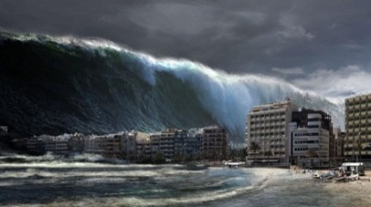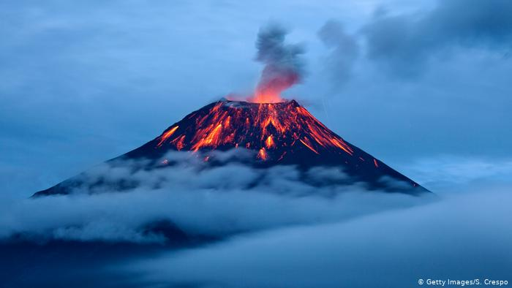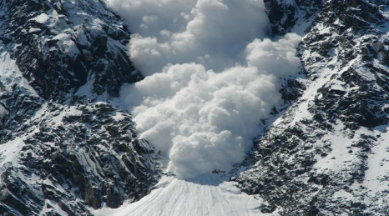
___________________ _____________________ ______________________

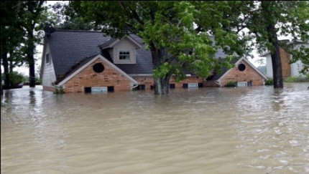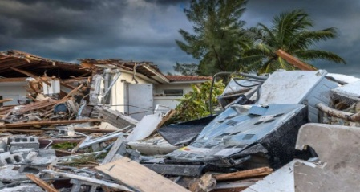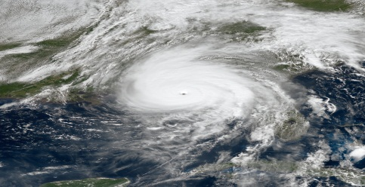
___________________ _____________________ ______________________

Unit 8 HEALTHY HABITS

FOOD
The next time you are in a supermarket, pay attention to what you see and smell. Usually fresh fruit and vegetables are near the entrance .Is there a reason for this? Yes, there is. Fresh food near the entrance makes people think all the items in the shop are fresh. Why is there a good smell of baking near the bread shelves? The bread is in plastic bags, but the smell (from bakery section) makes people feel hungry and then they buy more. And what is next to the checkout? How many bags of sugar or rice do you see there? How many eggs? None! This is the place for sweets and magazines and buys them, without thinking about how much money they are spending.
Task1. How do you say it in your language?
- Pay attention ___ 4. checkout ____
- Items ___ 5. None! ____
- Feel hungry ___ 6. without thinking ____

Task2. Find the words in the text that mean:
- Where you buy food and cleaning things door
- Places to put things in order
- Amount of coins and notes

Task3. Correct the mistakes in bold
- In a supermarket, the fresh fruit is usually near the checkout
- The fruit is the plastic bags
- The smell near the bread makes people feel thirsty
- There are sweets near the entrance
- People buy eggs without thinking

Task 4. Match A to B to complete the sentences about supermarkets
- Rice and sugar a) has got a good smell
- Bread b) are near the checkout
- Fruit and vegetables c) are fresh
- Sweets d) aren’t near the checkout

Task5. Answer the questions. Give full answer.
- Where are usually vegetables and fresh fruit in a supermarket?
- Why? ____________________________________________
- Why is the smell from the bakery section?
- What are the near the checkout?

Unit 9 CLOTHES AND FASION

Task2. What urban tribes do you know? Tick them
Emos | Floggers | Skaters | Rollingas | Hip-Hoppers | Hippies | Punks | Rockers | Darks | Pokemones

Task3. Read about Urban Tribes.

“Urban tribes are groups with common interest and preferences. The members of these micro groups have similar world views, dress styles and behavioral patterns. They listen to the same music, they share the same ideology, and they talk in the same way. ”

Nerds (nerd –socially inept)  They are members of the “digital culture”. They love computers and communicate on the internet with other members of their community. They’ve got all the software and they are very competitive. They use special language when they communicate with their friends on the net. | Punks  Punks wear mostly black, red or white clothes. They often listen to punk/emo/heavy or metal music. They don’t care what other people think of them. Punk is more than just music :it has deep philosophy, based on anarchist political views and liberation | Goths  They have their own music, fashion, literature and philosophy. They love black clothes, make up. Goths look depressed but they enjoy their lifestyle.  Goth literature includes dark poetry and fiction with topics like “Nobody can fell love intensely as I do”

Task4. Correct the statement that is not right.
- Urban tribes are small groups of people with different ideas, and opinions about life, music, and clothing.
- Nerds adore technology and they have their own way to communicate with their partners.
- Goths don’t wear makeup.
- Punks and Goths dress similarly
- Nerds like dancing , and going out with friends

Task 5. You have to choose 3people from the picture that are representative of a certain urban tribe .

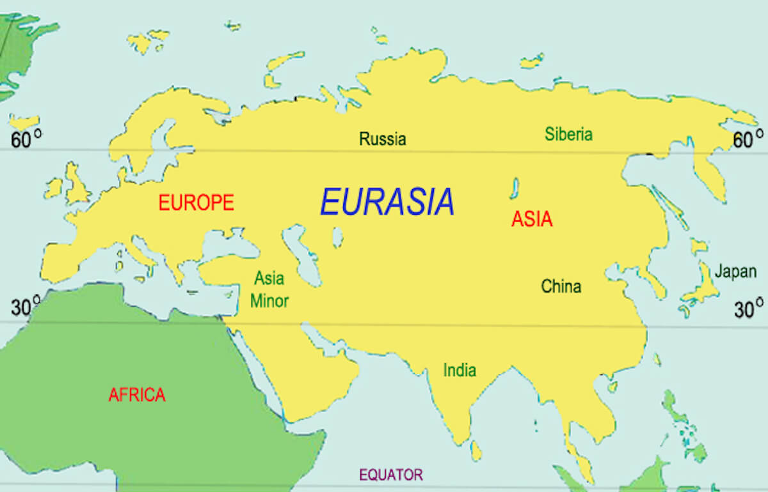

8th grade

Unit 1 OUR WORLD

THE PALACE OF PEACE AND RECONCILIATION

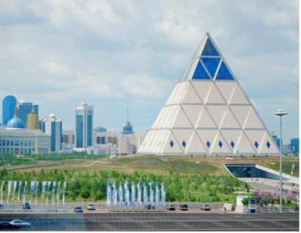

Task1. Look at the picture and read the text.

The Palace of Peace and Reconciliation is situated in Nur-Sultan, Kazakhstan. The idea of creating this structure was proposed by the First President N. Nazarbayev in 2003 at the First Congress of Leaders of World and Traditional Religions. The idea was to create a place embodying the unity, friendly and peaceful attitude of all Kazakhstan, a place where the Congresses of Leaders of World and Traditional Religions would be held and other significant events. The Palace of Peace and Reconciliation was officially opened in 2006.
The author of the project was the world-renowned British architect N. Foster. He owns such architectural creations as London City Hall, Torre Caja Skyscraper in Madrid, Hong Kong International Airport and many others. In addition, the uniqueness of the building is its golden cross-section: the base and height are equal to each other and are 62 meters. There are galleries, a conference hall, exhibition areas, a winter garden, a concert and opera hall for 1500 spectators. Its interior is made in burgundy and gold tones, and it is equipped with modern equipment, thanks to which high-quality sound is obtained. Near the stage, there is an orchestra pit 2.8 meters deep, designed for 80 musicians. There are also 25 makeup rooms.

Task2. Read the text again and decide if the sentences (1-5) are T (true) or F (false).

- The Palace of Peace and Reconciliation was officially opened in 2003. _____
- The author of the project is N. Nazarbayev. _____
- The uniqueness of the building is its golden cross-section. ____
- There are galleries, a conference hall, exhibition areas, a winter garden, a concert and opera hall for 1500 spectators. _____
- Near the stage is an orchestra pit 2.8 meters deep, designed for 80 musicians. _____

Task3. Choose the right answer.

- When was the idea of creating this structure proposed by N.Nazarbayev?
- in 2003
- in 2004
- in 2006
- Who was the author of the project?
- Nursultan Nazarbayev
- Norman Foster
- Brian Clarke
- In what colors is the interior of The Palace of Peace and Reconciliation made?
- black and white
- green and gold
- burgundy and gold
- Where is the orchestra pit situated?
- It is near the stage
- It is under the stage
- It is in behind the stage
- When the Palace of Peace and Reconciliation was was officially opened?
- in 2005
- in 2006
- in 2016

Task4. Word formation (nouns from verbs).
There are nouns formed from the verbs. Make verbs.

Verbs | Nouns
 | reconciliation
 | creations
 | exhibition
 | equipment

Unit 2 DAILY LIFE & SHOPPING

Task1. Read the text.
EVERYDAY LIFE

MR. PRIESTLEY: You all need the words and phrases we use to describe our daily actions, so suppose I tell you the things that I do, more or less, every day. By the way, which tense ought I to use for that, Olaf?
OLAF: I think you ought to use the Simple Present Tense.
MR. PRIESTLEY: Why?
OLAF: Because that is the tense generally used for actions that are “habitual” or repeated.
MR. PRIESTLEY: Very good, Olaf. Now I’ll begin: I wake up at about seven o’clock and then it is time for me to get up. I like a cold bath every morning, so I put on my dressing-gown and slippers and go to the bathroom. The water feels very cold on winter mornings, but I rub myself hard with the towel and soon I feel quite warm.
Then I shave, brush my teeth and wash my face and go back to the bedroom to dress. I comb my hair, take a clean handkerchief out of the drawer and go downstairs for breakfast at a quarter past eight. After breakfast I sit and read my morning paper and smoke a cigarette, or in summer I have a walk round my garden. I go into my study at nine o’clock and meet my students there, and the day’s work begins. At twelve-thirty I have a break for lunch. I usually have this at home, but sometimes I go out for lunch and have a chat with my friends before beginning work again at two o’clock. Then I have a cup of tea and a biscuit, and in summer I spend an hour or so in the garden and play a few games of tennis, or I go to the golf club and have a round of golf.
We have dinner about seven-thirty or eight o’clock, and then we sit and talk, listen to the radio or watch TV, or Mrs. Priestley plays the piano. Sometimes, in summer, we take out the car and go for a drive in the country; in winter we go to the cinema or the theatre. But that is not often. I have a lot of work to do, and usually after dinner or supper I go to my study and read or write until twelve or one o’clock.
That’s my day. Now, here is Mrs. Priestley to describe a woman’s day.

Task2. Translate the sentences into English using the words in bold from the text.

1. Я возвращаюсь домой со школы в 14.00.
Мектептен сағат 14.00 қайтамын.
2.Зимой необходимо одевать теплую одежду.
Қыс мезгілінде жылы киім кию қажет.
3. Летом люди плавают в реке.
Жаз мезгілінде адамдар көлде жүзеді.
4. Вечерами наша семья предпочитает пить чай на террассе.
Кешкі уақытта отбасымызбен террассада шай ішуді ұнатамыз.

Task2. Put the verb in the correct form.

1. She (to watch) TV every day.
2. I (to watch) TV since 2 o’ clock.
3. My father (to watch) TV last weekend.
4. The children (to watch) TV by the time the guests arrived.
5. Larry (to watch) TV when Wendy came into the room.

Task3. Answer the following questions according to the text.

1. What grammar tense is discussed in the text?
2. What time does Olaf wake up in the morning?
3. Where does Olaf like to walk in summer?
4. What does Mrs. Priestley likes to do in the evenings?

Task4. Write about your daily routines (120 words).

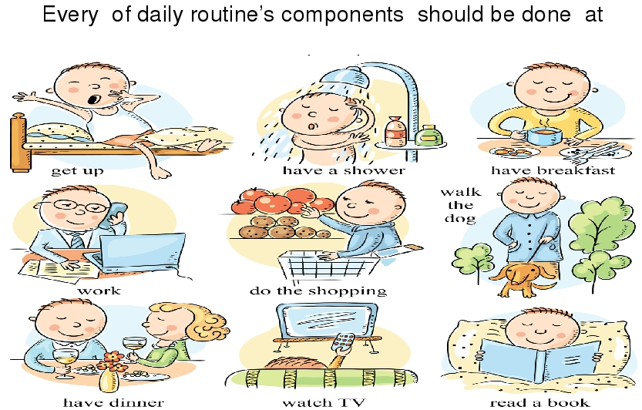

Unit 3 ENTERTAINMENT AND THE MEDIA

Task1. Read the text.
MASS MEDIA.
To live in the modern world is impossible without expanding your knowledge in all spheres. There are several ways of communicating the world of individuals-mass media, books, travelling, museums, meeting eminent people. Of all the existing ways, there are two which are the easiest; those are mass media and travelling. It’s not a secret the different media are used to communicate news and entertainment. They include print media and electronic media.
Mass media play an important role in our life. They are usually defined by encyclopedias as any of the means of communication, such as radio, television, newspapers, magazines, etc. that reach and influence a very large audience, at least as large as the whole population of a nation.
I believe mass media are so influential because they can be used for various purposes: popularization, education, entertainment etc.
Mass media play a crucial role in forming public opinion. But how much do the media influence the modern society? Early critiques suggested that the media destroys the individual’s capacity to act autonomously. Later studies, however, suggest a more complex interaction between the media and society. People actively interprete and evaluate the media and the information it provides.

Task2. Fill in the blanks. The first letter of each missing word has been given.

The mass media refers to the people and organizations that provide news and i………. (1) for the public. Until recently these were mainly n……….. (2), t……. (3), and r……… (4). Today, computers play a very big part. The I……….. (5) is a computer system that allows millions of people around the world to receive and exchange information about almost everything? Ordinary post has been taken over by e………. (6) which stands for e…….. (7) mail because it is sent m………… (8) to each other quickly and cheaply. Ordinary p……….. (9) is now referred to as “snail-mail” and one wonders if the p…….. (10) is a job in danger of extinction!

Task3. Complete the sentences using the words below:

• a comedy
• a drama series
• a presenter
• a newsreader
• a documentary
• a game show
• a chat show
• a soap opera
• a commentator
a) Did you see the first episode of the new ________ on TV last night? The actors were very good, and the story was very interesting but very sad.
b) Jill Newman is a _______ on breakfast television. She introduces the programme and talks to guests. Before that, she was a __________n News at Ten. c) Did you watch the ___________ about the history of India?
d) It’s on at seven o’clock four times a week. It’s my favourite ________. I know the people in the programme. They are like friends.
e) It’s a fantastic _______. If you answer ten questions correctly, you can win a million pounds. f) Did you see Tom Cruise on TV last night? He was interviewed by Jonathan Pross on his new ________.
g) I think Jon Botson is a great _______. He gets very excited when he describes somebody scoring a goal in a football match.
h) It was a very funny _____. I laughed and laughed.

Unit 4 SPORT, HEALTH AND EXERCISE

SPORT, HEALTH AND EXERCISE
Task1. Read the text. Complete the passages using the words:

board | becomes | practice | sport
foot | sometimes | body | balance
feet
Skateboarding has become a very popular 1) ______. All a person needs to enjoy this sport is a skateboard, good 2) _______, and some 3) ________. It is a good idea to use safety helmets and kneepads because even the best skateboarders fall 4) _________. To begin skateboarding, put one foot on the skateboard and push forward with the other 5)____. When you get moving fast enough put both 6) _______on the 7) ____________. You keep your balance by moving your arms and 8) _________. The more you practice the easier it 9) ___________.

Task2. Match the pictures with appropriate words.
- Racket | - 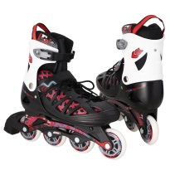
- Net

- Goal | - 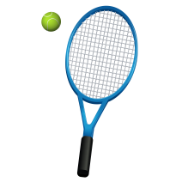
- Rollerblades
- Swimming pool | - 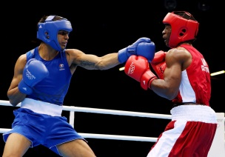
- Boxing
- Basketball

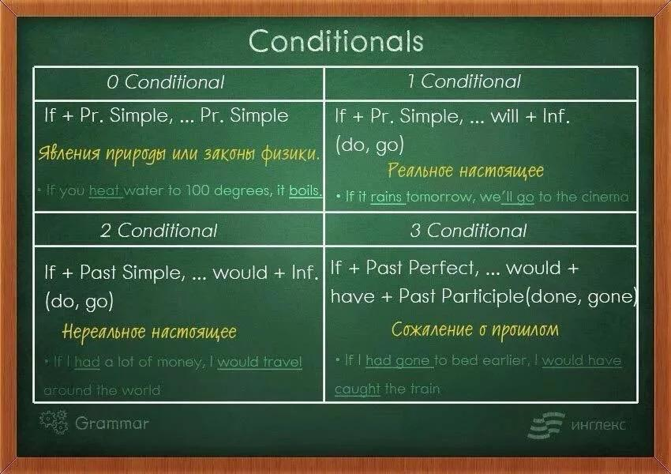

Task3. Complete the Conditional Sentences. Decide whether to use Type I or II.
1. If they go to Washington, they (see) _______ the White House.
2. If she (have) ________a hamster, she would call him Fred.
3. If he gave her a sweet, she (stop) _______crying.
4. If he (arrive) ______ later, he will take a taxi.
5. We would understand him if he (speak) _______slowly.
6. Andy (cook) ________ dinner if we buy the food.

Unit 5 READING FOR PLEASURE

Task1. Before reading. Do the preparation task first. Then read the text and do the exercises. Match the definitions (a–h) with the vocabulary (1–8).

VOCABULARY
1. …… a tribe
2. …… fake
3. …… to support
4. …… to worship
5. …… origin
6. …… a spirit
7. …… a weapon
8. …… to invade

DEFINITIONS
a. the explanation for how something started
b. the part of a living thing which is not the body and you can’t see or touch it
c. to pray to
d. a group of people, usually connected to each other by place or culture
e. something used to hit or hurt people
f. to attack a place with an army
g. to make something stronger
h. looks real but is not

Task2. Read the text.

The legend of fairies

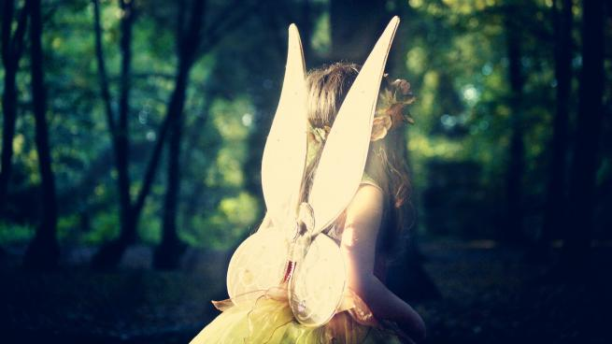

(1) Fairies today are the stuff of children's stories, little magical people with wings, often shining with light. Typically pretty and female, like Tinkerbell in Peter Pan, they usually use their magic to do small things and are mostly friendly to humans.
(2) We owe many of our modern ideas about fairies to Shakespeare and stories from the 18th and 19th centuries. Although we can see the origins of fairies as far back as the Ancient Greeks, we can see similar creatures in many cultures. The earliest fairy-like creatures can be found in the Greek idea that trees and rivers had spirits called dryads and nymphs. Some people think these creatures were originally the gods of earlier, pagan religions that worshipped nature. They were replaced by the Greek and Roman gods, and then later by the Christian God, and became smaller, less powerful figures as they lost importance.
(3) Another explanation suggests the origin of fairies is a memory of real people, not spirits. So, for example, when tribes with metal weapons invaded land where people only used stone weapons, some of the people escaped and hid in forests and caves. Further support for this idea is that fairies were thought to be afraid of iron and could not touch it. Living outside of society, the hiding people probably stole food and attacked villages. This might explain why fairies were often described as playing tricks on humans. Hundreds of years ago, people actually believed that fairies stole new babies and replaced them with a 'changeling' – a fairy baby – or that they took new mothers and made them feed fairy babies with their milk.
(4) While most people no longer believe in fairies, only a hundred years ago some people were very willing to think they might exist. In 1917, 16-year-old Elsie Wright took two photos of her cousin, nine-year-old Frances Griffiths, sitting with fairies. Some photography experts thought they were fake, while others weren't sure. But Arthur Conan Doyle, the writer of the Sherlock Holmes detective stories, believed they were real. He published the original pictures, and three more the girls took for him, in a magazine called The Strand, in 1920. The girls only admitted the photos were fake years later in 1983, created using pictures of dancers that Elsie copied from a book.

Task3. Are the sentences true or false or is the information not given?
- Fairies are not usually male.
A.True
B.False
C.Not given
2) Newer religions changed how people thought of fairies.
A.True
B.False
C.Not given
3) People used iron to protect themselves from fairies.
A.True

B.False
C.Not given
4) People thought very good babies were presents from the fairies.
A.True
B.False
C.Not give
5) Arthur Conan Doyle created some of the fake photos.
A.
True
B.False
C.Not given

Task4. Choose the best answer.

1) In paragraph 1, the word they refer to …
A. fairies.
B. children.
C. stories.
2) In paragraph 2, the words these creatures refer to …
A. tree and rivers.
B. the spirits of trees and rivers.
C. the Ancient Greek people.
3. In paragraph 2, the word they refer to …
A. pagan gods.
B. pagan religions.
C. Greek and Roman gods.
4. In paragraph 3, the words this idea refers to …
A. the idea that fairies were based on people.
B. the idea that fairies used metal weapons.
C. the idea that fairies used stone tools.
5. In paragraph 3, the word this refers to …
A. the fact that fairies were thought to be afraid of iron.
B. stolen food.
C. the possibility that hiding people stole food and attacked villages.
6. In paragraph 4, the word more refers to …
A. the girls.
B. the photos.
C. the fairies.

Unit 6 THE NATURAL WORLD

Task1. Read the text and answer the questions.

“Tortoises”

The Galapagos Islands are situated in the Pacific Ocean to the west of South America. There are many species of reptiles, birds and plants which are only found here. These animals survived on the islands because they were isolated from dangerous animals, disease and people.
The Galapagos Islands are famous for huge tortoises. This tortoise can live for about 100 years and can weigh about 270 kilos. They are so heavy that only six or eight people can lift them.
Not long ago sailors, explorers, hunters and fishermen came to the islands and killed the slow, friendly animals for their meat. Some tortoises were taken off the islands for zoos or private collections.
These tortoises are now endangered animals. There are now only about 6,000 left. Now, they and their home are protected.

Answer the questions to the text:

- What animals live in the Galapagos Islands?
- What are the tortoises like?
- Why are they endangered animal now?

Task2. Decide, are the sentences true (T) or false (F)?

- Many species of reptiles, birds and plants in the Pacific Ocean. __________
- The Galapagos Islands are famous for huge crocodiles. ____________
- Tortoise can live for about 100 years. _____________
- Tortoise can weigh about 570 kilos. _________
- There are now only about 6,000 species of the Galapagos tortoises’ left._______

Grammar tasks.
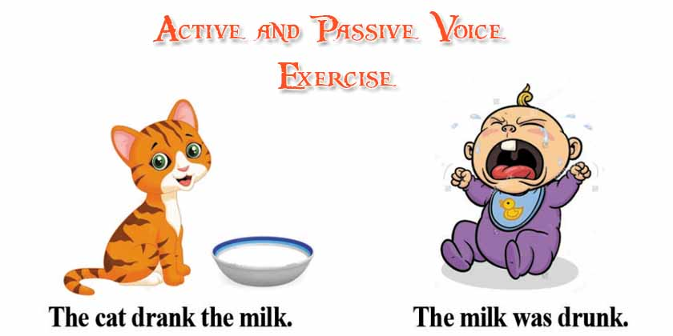

Task3. Rewrite the sentences in Passive voice.

1. John cleaned the bathroom. ______________________________________
2. The electricians test the fire alarm. _________________________________
3. Our dog is catching the cat. _______________________________________

Task4. Rewrite the sentences in Active voice.

1. Coffee is sold by Marie.
2. The telephone was invented by Alexander Graham Bell.
3. The bag was packed by his mother.

Unit 7 TRAVEL & TRANSPORT

Task1. Read the text
A travel guide

Whether you’re travelling to the islands or the mountains of Thailand, you’re likely to spend at least one night in its capital city on the way. Bangkok might be noisy and polluted but it’s also an exciting city with plenty of things to see and do. Why not make it a longer stay?
Where to stay
The Khao San Road was a famous traveller spot even before Leonardo di Caprio’s character in the film The Beach stayed there. But it’s noisy, not very pretty and not very Thai. For something more authentic, Phra Kanong offers an alternative place to stay, with its fantastic street markets where every day Bangkok people eat, work and live. It’s not as convenient for the main tourist sites, but it has a Skytrain station so you can be at the Grand Palace in 20 minutes.
How to get around
Bangkok’s traffic can be a nightmare. Sure, you can easily take a taxi – if you want to spend hours stuck in traffic jams – but there are two much better ways to get around the city. To explore the temples and historical sites, catch an express boat river taxi or a longtail boat along the Chao Phraya River and the canals. For the modern part of the city, the Skytrain is a fast, cheap way to travel from the river to the shopping malls and nightlife of Sukhumvit, and the famous Chatuchak street market.
Where to eat
The simple answer is: everywhere! Thai street food is among the best in the world, and for around $5 you can eat a filling and delicious meal. Some food stands have little plastic seats where you can sit and eat and they cook the same dish over and over, like fried chicken on rice or Pad Thai noodles. Head for Chinatown – Yaowarat Street – and choose whatever looks most interesting from the many excellent Chinese and Thai restaurants and food stands.
What to do
After you’ve seen the main sites like the Giant Buddha at the temple of Wat Pho and the spectacular Grand Palace, and shopped at Chatuchak market, check out the snake farm and watch the live snake show. You can even touch a snake yourself if you want to!

Task2. Match the definitions (a–f) with the vocabulary (1–6).

Vocabulary
1. …… polluted
2. …… noodles
3. …… alternative
4. Authentic
5. …… express
6. A stand

Definition
a. real or normal for a place, not specially for tourists
b. dirty from traffic or chemicals
c. fast
d. another way to do something
e. a table where food or other things are sold in a market
f. a long, thin food made from flour, water and eggs

Task3. Match the Bangkok landmarks and places with the descriptions.

Wat Pho | Khao San Road | Sukhumvit
Yaowarat Street | Phra Kanong | Chao Phraya

1. ………………………………… a place that you might see in the film The Beach.
2. ………………………………… a place where local Thai people go.
3. ………………………………… an alternative route through the city.
4. ………………………………… a place to go for shopping and bars.
5. ………………………………… a place to go for food.
6. ………………………………… an important sightseeing spot.

Task4. Are the sentences true or false?

№ | Sentences | True | False
1. | One night is enough time to see Bangkok.
2. | Khao San Road is an authentic Thai area of the city.
3. | Phra Kanong is further away from the main tourist sites than Khao San Road is.
4. | The river boat taxis often get stuck in traffic too.
5. | Taking the Skytrain is a faster way to see the city than going by taxi.
6. | You need to choose where to eat carefully, as not everywhere is good.

Task5. Discussion.

Would you like to visit Bangkok? Why or why not?

Unit 8 FOOD & DRINK

Task 1. Read the text and answer the questions which are given before text.

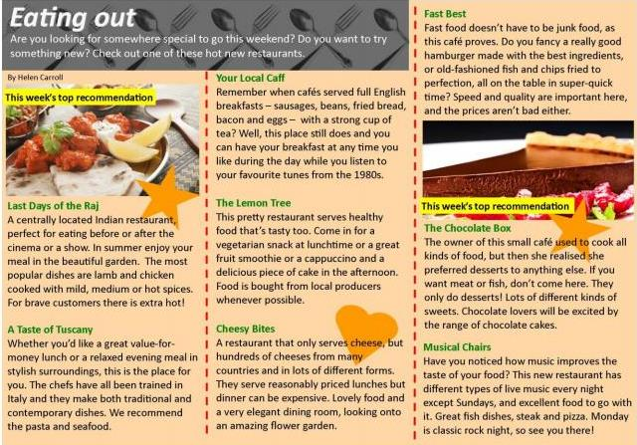

Task2. Write the names of the food and drink in the boxes below the picture.
pizza steak hamburger fish
cappuccino fruit smoothie English breakfast pasta

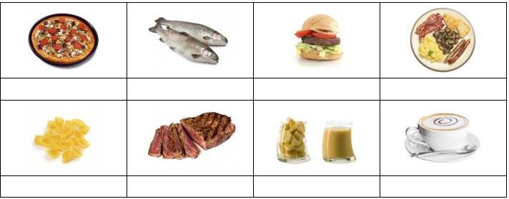
Task3. Check your understanding: matching.
Match the people with the best restaurant for them. Write the restaurant names below.
Your Local Caff The Lemon Tree Fast Best
The Chocolate Box Last Days of the Raj A Taste of Tuscany

My girlfriend and I are vegetarian. Could you recommend a suitable restaurant for us?  Tom, 18 years old. | Restaurant: ____________________
My friend has a sweet tooth and I want to take her somewhere special this weekend.  Lucy, 16 years old. | Restaurant: ____________________
My mates and I all love spicy food. Can you recommend somewhere good for us to go tonight?  Dino, 21 years old. | Restaurant: ____________________
I only get 30 minutes off for lunch and I'm in a hurry. Where can I get something quick to eat?  Melissa, 27 years old. | Restaurant: ____________________
Breakfast is the most important meal of the day in my opinion. Do you know anywhere that serves a good brekkie?  Micky, 38 years old. | Restaurant: ____________________
We love Italian food, especially pasta. Everyone loves Italian, don't they? Any good Italians near here?  Momo, 22 years old. | Restaurant: ____________________

Task4. Write the names of restaurants from the article in the box.

1. Which restaurant(s) serve hot and spicy food? __________________________
2. Which restaurant(s) only have desserts and __________________________
sweets?
3. In which restaurant(s) can you listen to some __________________________
great music?
4. Which restaurant(s) are good for people who __________________________
don't eat meat?
5. Which restaurant(s) employ staff trained in __________________________
Europe?
6. Which restaurant(s) serve an all-day breakfast __________________________
including sausages, bacon and eggs?
Task5. Vocabulary box. Write any new words you have learned in this lesson.

Unit 9 THE WORLD OF WORK

Task1. Pre-reading activity. Find out 15 jobs.

P | F | V | D | B | C | H | E | F | N | J | N | L
L | G | E | G | T | U | T | O | R | M | U | E | A
U | F | T | D | E | N | T | I | S | T | D | W | W
M | S | J | T | E | A | C | H | E | R | G | S | Y
B | U | K | B | Q | S | D | C | V | B | E | R | E
E | R | F | I | R | E | F | I | G | H | T | E | R
R | G | O | I | A | P | I | L | O | T | O | A | U
W | E | S | D | N | U | R | S | E | A | G | D | Y
P | O | L | I | C | E | O | F | F | I | C | E | R
S | N | S | P | O | S | T | M | A | N | P | R | T

1.___________
2.___________
3.___________
4.___________
5.___________
6.___________
7.___________
8.___________
9.___________
10.__________
11.__________
12.__________
13.__________
14.__________
15.__________

Task2. Read short adverts and match the adverts with the job descriptions
Finding a job
  - Babysitter needed
We need a babysitter to look after our two boys aged 5 and 7 after schools from 4 p.m. – 6 p.m., Mon – Fri. £40 a week. Call Mary on 678345211.

  - Newspaper round before school
We need young people to deliver newspapers on Mon, Wed and Fri mornings. The paper round takes 30 minutes in the village of Clanbrook. Papers must be delivered before 8 a.m. and you must have your own bike. Interested? Ask for more info at Clanbrook post office.

  - CITY MUSEUM
Holiday job. Do you want to earn some extra money this summer? Do you speak another language? We need French, Spanish or German speakers to work for us in the City Museum shop Tuesday – Saturday. Send your CV to citymuseum@shopjob.lkj

  - PART-TIME WORK
Munchies Café. We are looking for breakfast and lunchtime staff to work in our café on Saturdays. Come in (8 a.m. – 4 p.m.) or call Bella on 612398745 (after 4 p.m.)

advert A | Looking after children.
advert B | Working in a shop.
advert C | Working in a small restaurant.
advert D | Delivering newspapers.

Task3. Are the sentences true or false?

- In advert A, the babysitter can get more than £40 a week.
- In advert D, you don't need to work in the evenings.
- In advert B, the paper round should take about half an hour.
- In advert C, you have to work five days a week.
- In advert D, you should call Bella in the morning.
- In advert B, you should contact the newspaper delivery boy for more information.
- In advert D, you need to work full-time.
- In advert C, you need to contact the museum by telephone.

Grammar.
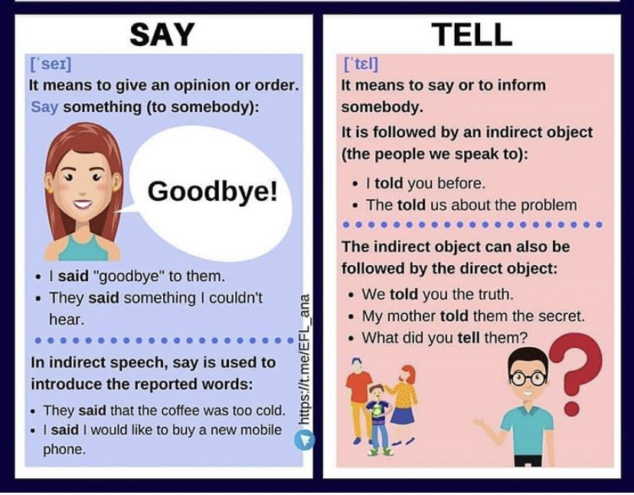

Task4. Fill in SAID or TOLD.

1. I _________ nothing at all.
2. I _________ them nothing.
3. Who _________ it’s right?
4. Who _________ him the news?
5. He _________ it was a mistake.
6. And then she _________ something strange.
7. The teacher _________ us to bring the textbooks.

9th grade

Unit 1 HOBBIES & QUALITIES

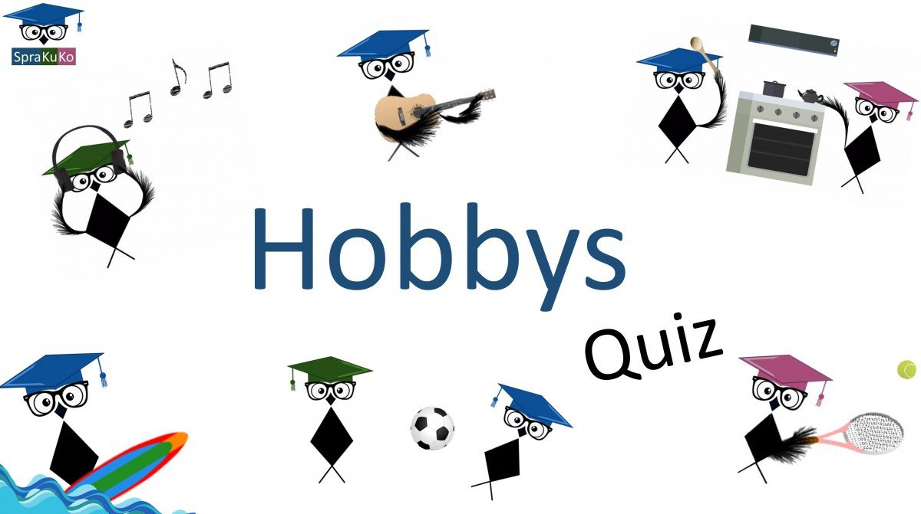
How to Find a Hobby ByTara Parker-Pope
Task1. Complete the sentences with these words: quest, neglected, toward, leisure, arthritis, pressure , engage, pursuits, benefits, dealt, satisfaction, diverse, transferable.
In your 1____ for a balanced life, have you 2 ______your hobbies? As children, we are experts at finding hobbies. We play sports, take dance and music lessons, collect action figures and spend our days learning everything from languages to wood shop. But somewhere on the path to adulthood, we stop trying new things and spend less time on our non-career interests. It’s not too late. Use this guide to get inspired, spark your interests and follow your passion 3______ a new hobby.
Let’s start with some science. A large body of research suggests that how you spend 4______time matters to your health, and that your hobbies are good for you in many ways.
In 2010, a team of researchers from universities in Kansas, Pittsburgh and Texas published the results of four large studies with a total of 1,399 participants, including men and women with various health problems, such as upper respiratory illness, _5_____and breast cancer. The researchers developed a scale called the Pittsburgh Enjoyable Activities Test to measure the effect of hobbies and leisure on overall health. Here’s what they found:
Better physical health. People who scored higher on the enjoyable activities test had lower body mass index, smaller waists, lower blood 6_____, lower stress hormones and better overall physical function. While it’s possible that people who start out healthy are more likely to 7 _____ in hobbies, the findings are consistent with other research showing that having hobbies and other leisure 8 _____ is associated with a variety of 9 ____, including less severe disease and greater longevity.
More sleep. While you may think that a hobby will take up too much of your leisure time or cut into your sleep, the Pittsburgh study showed that people who spent more time on their hobbies actually got better sleep.
Lower stress. A large body of research shows that leisure activities can help reduce stress. The Pittsburgh study showed that people who took part in a lot of enjoyable activities 10 ____ better with stressful life events. People who scored high on the enjoyable activities test showed lower levels of negative moods and depression, and higher positive attitudes than their low-scoring counterparts.
Happiness. People who said they participated often in enjoyable activities also had greater life _11 _______and felt their lives had a greater sense of purpose and meaning.
More friends. Notably, spending more time on hobbies and leisure pursuits was associated with having a larger and more 12 ____ social network. And we know that a strong social network is a key factor in healthy aging.
And there’s one additional benefit to having a hobby that may surprise you.
Improved work performance. A study at San Francisco State University found that employees who had creative outlets outside of the office were better at creative problem solving on the job. The findings were based on studies of 430 workers and military personnel that found that having a hobby gave workers a chance to recover from the demands of their jobs, increased their sense of control and in some cases challenged them to learn new skills that were 13 ______to work.
A word to the wise: Don’t pick a hobby because it will help you at work. Pick a hobby that makes you happy, and any improvement in your work will just be a bonus!
Task2. Find true [T] false [F] sentences.
- The researchers developed a scale to measure the effect of hobbies and leisure on psychology. T/F
- Pittsburgh study showed that people who spent more time on their hobbies got better sleep. T/F
- A large body of research shows that leisure activities can help reduce stress.
- People who scored high on the enjoyable activities test showed higher levels of negative moods and depression, and higher positive attitudes than their low-scoring counterparts. T/F
Task3. Ask 5 questions.
Task 1 Complete the text with tese words: spirit, assumed, properly, unfortunately, almost, achievers, self-esteem, equipment, humble, competitive, embarrassment, attitude,

Unit 2 EXERCISE AND SPORT

Sports at School
A Sarah Jones Looking back, I did enjoy sports lessons at school, even though I think most schools in those days 1________sports were basically for boys, and girls weren't encouraged to do well at sports. That 2 _____really annoys me, because the whole point of sports at school is to help kids develop the right attitudes, and it doesn't matter really how good you are. If you can't run as fast as an Olympic athlete, that doesn't matter -what matters is that you run as fast as you can. Schools are highly 3______environments and sports can teach children the importance of teamwork. To do well in 4______ everything else at school, like math or history, you are rewarded for individual effort, but sports are about working together towards a common goal. Sports at school give children who are not high 5_______ a chance to excel at something.
B Matt Brown My own memories of sports lessons at school aren't particularly good, but that's mainly because of the type of school I went to. It was very unusual by British standards, with old-fashioned ways of teaching, and the head teacher didn't really think sports mattered at all. The school rarely organized sports events and never invested in sports 6____. There was very little emphasis on the importance of eating sensibly and the benefits of keeping fit and exercising 7 _____. I believe that issues like obesity, anorexia, nutritional value of food, etc. should be included in sports lessons at school. Children should be encouraged to take part in competitive sports. Being competitive is part of human nature, and doing sports can provide an excellent outlet for this aggressiveness. Winning at sports can build up your 8____ and confidence. On the other hand, since you can't expect to win every time, sports can also teach you how to be 9 _______ and realistic.
C Ross Wright There are obvious benefits in having good sports classes at school. Children stay fit and learn the importance of fair play. Schools can introduce children to sports they would never otherwise have the opportunity of doing. For instance, I grew up in a big city, and we hardly ever travelled to the countryside as a family. At school we had a climbing wall in the gym, and we learnt rock climbing in sports class. When I moved to Europe, I took up rock climbing and was surprised by how good I was at it. Schools should offer a wide range of sports from the most popular ones, like football and basketball, to the less popular ones, like table tennis and climbing. 10_______, sports are often regarded as a sort of optional extra by certain schools and this is also reflected in the children's attitude to them.
D Kate Robinson The main point about sports is that they encourage peaceful competition. I think that's the basis of the Olympic 11______ of Classical Greece, which nowadays is more important than ever before. Sports can teach you how to discipline yourself, how to remain focused on what you're doing and how to apply yourself to achieving a goal. I don't think sports are really about the sort of aggression and rage that you see sometimes in football matches, for instance. I certainly think teachers should discourage any form of aggression during sports classes. On top of that, we need to be more sensitive towards the feelings of children who are not fit or good at sports. Taking part in a sports lesson can be a major source of 12________and a traumatic experience for less athletic children.
You are going to read part of an article in which four people talk about the sports lessons they had at school.

Task 2 For questions 1-10 choose from the people (A-D). The people may be chosen more than once

. 1. Which person thinks sports encourage cooperation?
2. Which person believes that experience of losing is important? ..........
3. Which person thinks one benefit of sports is learning to concentrate? ...........
4. Which person compares academic subjects to sports?
5. Which person believes the Olympic spirit is essential today?
6. Which person thinks sports help non-academic pupils?
7. Which person thinks sports can teach objectivity and justice?
8. Which person thinks schools should teach unusual sports?
9. Which person thinks diet and health should be taught with sports?
10. Which person thinks sports can make some children feel uncomfortable?
..........

Task 3 Match the words

Old athelete
Olimpic wall
Football fashioned
Wide matches
Children’s range

Unit 3 EARTH & OUR PLACE ON IT

HOBBIES & QUALITIES

The Earth
Task1. Complete the sentences with these words: goes around, move, bright, species, covered, inside, surface, space, leap, along, additional, planet.
- The Earth is the third planet from the Sun and it is the only 1______known to have life on it. The Earth formed around 4.5 billion years ago. It is one of four rocky planets on the 2______ of the Solar System. The other three are Mercury, Venus, and Mars.
(B) The large mass of the Sun makes the Earth move around it, just as the mass of the Earth makes the Moon 3_______around it. The Earth also turns round in 4______, so different parts face the Sun at different times. The Earth 5________the Sun once (one "year") for every 365¼ times it turns all the way around (one "day").
(C) The Moon goes around the Earth about every 27⅓ days, and reflects light from the Sun. As the Earth goes round the Sun at the same time, the changing light of the Moon takes about 29½ days to go from dark to 6______to dark again. That is where the idea of "month" came from. However, now most months have 30 or 31 days so they fit into one year.
(D) The Earth is the only planet in our Solar System that has a large amount of liquid water. About 71% of the surface of the Earth is 7_______by oceans. Because of this, it is sometimes called the "Blue Planet".
(E) Because of its water, the Earth is
home to millions of 8_______ of plants and animals. The things that live on Earth have changed its 9______greatly. For example, early cyanobacteria changed the air and gave it oxygen. The living part of the Earth's surface is called the "biosphere". (F) The Earth is part of the eight planets and many thousands of small bodies that move around the Sun as its Solar System. The Solar System is moving through the Orion Arm of the Milky Way Galaxy now, and will be for about the next 10,000 years. (G) The Earth is generally 150,000,000 kilometers or 93,000,000 miles away from the Sun (this distance is named an "Astronomical Unit"). The Earth moves 10________its way at an average speed of about 30 km or 19 mi a second. The Earth turns all the way around about 365¼ times in the time it takes for the Earth to go all the way around the Sun. To make up this extra bit of a day every year, an 11_________day is used every four years. This is named a "12______ year".
(H) The Moon goes around the Earth at an average distance of 400,000 kilometers (250,000 mi). It is locked to Earth, so that it always has the same half facing the Earth; the other half is called the "dark side of the Moon". It takes about 27⅓ days for the Moon to go all the way around the Earth but, because the Earth is moving around the Sun at the same time, it takes about 29½ days for the Moon to go from dark to bright to dark again. This is where the word "month" came from, even though most months now have 30 or 31 days.
Task2. The text has eight paragraphs A-H. Which paragraph contains the following information? Write the correct letter, A–H, in boxes 1–8 .
- Earth’s natural satellite ______________
- Distance between Earth and Sun _______
- General information about Earth________
- The Solar System
- Length of most months
- Another name for Earth
- The living part of the Earth's surface
- The movements of Earth around the Sun
Task3. Complete the sentences below.
Choose NO MORE THAN THREE WORDS from the text for each answer.
- Apart from Earth, other rocky planets in our Solar Systems are Venus, Mars and _______
- Moon ______ from the Sun on Earth.
- There are millions of _________of plants and animals that inhabit Earth.
- Now the Solar System is travelling through _______.
- The dark side of the Moon is the side, which ______faces Earth.
Task4. Ask 5 questions according to the text.

Unit 4 CHARITIES & CONFLICTS

HOBBIES & QUALITIES

Task1. Fill in the gaps with these words: over control, tidy, behavior, arrange, to prohibit, appreciate, put off, naughty, advice, support, declared, fuss.
When I was as old as my daughter is now, my parents were not happy with my 1 . I argued with them, ignored their orders and didn’t 2 their care. Now I see how wrong I was; they wished me only good. Now I have a teenage daughter myself. I think that the main thing with teenagers not to 3 their lives and not to take care of them too much. It sounds strange, doesn’t it? But I mean that parents shouldn’t check if their children’s schoolbag has been packed or their school uniforms are clean and 4 . I never tell my daughter Aruzhan that she shouldn’t drop her school blazer in the corridor or that she should go to bed on time. I accept that she can plan her day and keep her school uniform wherever she likes: on the floor or under the bed or in her own schoolbag. But she should look tidy at school and shouldn’t make a 5 in the morning if she is late and her dress doesn’t look right.
I don’t 6 the idea of prohibiting something without a good reason. Last month Aruzhan 7 that she was grown up enough to arrange home parties for her friends. I didn’t object to it but explained to Aruzhan that her responsibility was not only to make up the list of the guests but to manage the whole event: to 8 the time that fits the plans of the family, to think about snacks and drinks beforehand, to make up a scenario for the party and to find time to tidy up the flat before and after party. I asked her to make up a kind of a business plan for the event and if everything was OK, there was really no reason 9 it, was there?
Aruzhan 10 the party several times. She did it, not because I didn’t let her invite the friends, but because she, herself, couldn’t prepare everything on time she acted like a grown-up, not an 11 demanding child.
I’m sure that my tactic works with my daughter. She understands now why I don’t allow her certain things. She sees the reason behind it instead of as a parent’s wishing to treat her as a child. She often asks for my 12 and appreciates it when I give it to her. In her turn, she tries to support me in difficult situations. She understands that it’s not easy to be adult and independent and to manage life as best you can.

Task2. Find the sentence that is not true.
1.Aruzhan had to put off the party because her mother didn’t let her invite the friends she wanted.
2. Aruzhan thought that she was grown-up enough to arrange a party.
3. Aruzhan accepted that arranging the party is not only making a list of the guests.
4. It tooks Aruzhan a lot of time to arrange everything necessary for the party.

Task3. Complete the sentence
Aruzhan’s mother thinks that the best way to treat teenagers is …
A) To prohibit everything
B) To let them do whatever they like.
C) To make them realize responsibility for their actions.
D) To make them do what their parents tell them to do.

Task4. Answer the questions:
1. What does the author say about her behavior?
2. What was happen when her daughter wanted to arrange home party?
3. Is it easy to be adult and independent?
4. What tactic does the author advice?

Unit 5 READING FOR PLEASURE

HOBBIES & QUALITIES

For billions of people around the world, January the 1st, 2020 seemed like a great day. It was the start of a year that sounded like science fiction -2020. Many people had great hopes for the year ahead. Few knew what a rollercoaster ride 2020 would be and how the world would change. The year has been dominated by the COVID-19 pandemic. This has brought hundreds of thousands of deaths, economic chaos, lockdowns and masked populations. Another huge event was the death of George Floyd at the hands of U.S. police in July. This sparked the Black Lives Matter movement and global protests. The year ended with Joe Biden being voted in as the President-elect of the USA.Different people will have different memories of 2020. Our reporters asked people around the world to tell us what they will remember 2020 for. Ahmed Hussein from Lebanon said he would never forget the massive explosion at a Beirut port in August that killed at least 190 people. He said he thanked God none of his family or friends were hurt, but was sad at the destruction of his city. Lucy Baxter, a nurse in the UK, said her happiest moment came with the news of the vaccines for COVID-19. She said she could see light at the end of a long and dark tunnel. Ayumi Miyamoto of Japan was saddened by the postponement of the Tokyo Olympics but is happy they will go ahead in 2021. She said 2021 would be a good year.
Task1. Vocabulary Matching
1. billion A statement or action expressing dislike of something
2. Science fiction b.Had a big influence on; exercised control over.
3. Dominated c.Total disorder and confusion.
4. Pandemic d.A one followed by nine zeroes (1,000,000,000).
5. Chaos e.Wearing a covering over the face.
6. Masked f.Stories about what we imagine the future to be like, or about space or time travel and life on other planets.
7. Protest g.Of a disease that is all over a whole country or the world.
Task2. Find true false sentences

a.The article said millionsof people thought 2020 would be a great year.T / F
b.The article says there is a science fiction movie about the year 2020.T / F
c.The article says 2020 was like a rollercoaster ride.T / F
d.The article mentioned economic chaos and lockdowns.T / F
e.Reporters asked people in India about their memories of 2020.T / F
f.A man was sad about the explosion in Beirut in August. T / F
.A nurse was happy about vaccines being discovered for COVID-19.T / F
h.A Japanese woman thinks 2021 will be equally bad.T / F

Task3. Synonym Match

1.great a) enormous
2.ahead b) disorganization
3.chaos c) dispirited.
4.huge d) demonstrations
5.protests e) blast.
6.memories f) to come
7.explosion g) ruination
8.destruction h) take place
9.saddened i) wonderful
10.go ahead j).recollections

Task4. Answer the questions

1. What does the article say seemed like a great day?
2. What does the article say 2020 sounded like?
3. What does the article compare 2020 to?
4. What kind of chaos does the article mention?
5. What movement does the article mention?

Unit 6 MUSIC & FILM

HOBBIES & QUALITIES

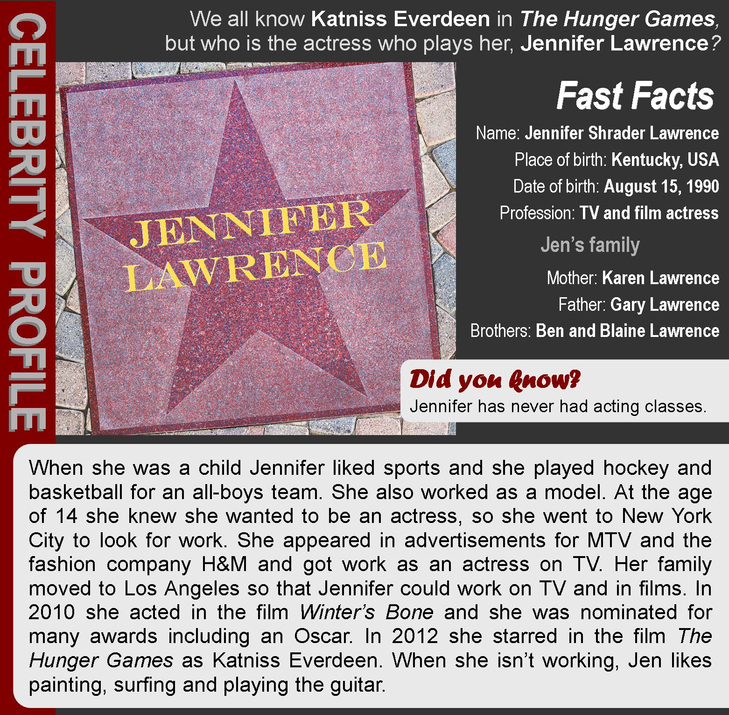

Task1. Put these sentences about Jennifer Lawrence's life in the correct order.
- At school she played basketball for a boys’ team
- She played Katniss Everdeen in The Hunger Games
- She appeared on TV for the first time
- She was nominated for an Oscar
- Jennifer was born in Kentucky
- She moved to New York
- She moved to Los Angeles

Task2. Are the sentences true or false?
- Jennifer is American. T/F
- .Jennifer was born in July. T/F
- She has two brothers. T/F
- Jennifer took acting classes at school. T/F
- Jennifer has done some modelling. T/F
- Jennifer was nominated for an Oscar in 2010. T/F
- She likes playing the piano. T/F
- Jennifer's family supported her reams to be an actress. T/F

Task3. Answer the questions
- What sports did Jennifer play at school?
- Basketball
- Surfing
- Hockey
- Tennis
- What films has Jennifer Lawrence starred in?
- Titanic
- Transformers
- Winter’s Bone
- The Hunger Games
- What cities has she lived in?
- London
- Los Angeles
- Miami
- New York
- What jobs has she done?
- Actress
- Model
- Fashion designer
- Waitress
- What does Jennifer do in her free time?
- Play hockey
- Painting
- Surfing
- Play the guitar
- What are her two brothers called?
- Karen
- Ben
- Gary
- Blaine
Task4. Tell about your favorite actor (-ress)?

Unit 7 TRAVEL & TOURISM

HOBBIES & QUALITIES

Phi Phi Island Resort
Task1. Complete the text: crop page, jutting, although, snorkeler’s, resemble, prominence, claims, infringed, islands, environment, limestone, seclusion
The “Phi Phi Island Resort” is located in Phi Phi Leh Island in Thailand, between the large island of Phuket and the west Strait of Malacca coast of the mainland. Phi Phi consists of six small islands 46km south of Phuket. Fine sandy beaches give way to soaring _1_____cliffs to form spectacular scenery. Add crystal clear water, a refreshing lack of roads, plus a laid-back lifestyle, and it's easy to see why Phi Phi is one of southern Thailand's most popular destinations. The _2____are administratively part of Krabi province. Ko Phi Phi is the largest island of the group, and is the most populated island of the group, _3___the beaches of the second largest island, Ko Phi Phi Leh are visited by many people as well. The rest of the islands in the group, including Bida Nok, Bida Noi, and Bamboo Island are not much more than large limestone rocks _4____out of the sea. The Islands are reachable by speedboats or Long-tail boats most often from Krabi Town or from various piers in Phuket Province. The islands came to worldwide _5_____when Ko Phi Phi was used as a location for the 2000 British-American film The Beach. This attracted criticism, with _6____that the film company had damaged the island's environment, since the producers bulldozed beach areas and planted palm trees to make it _7____ description in the book, an accusation the film's makers contest. An increase in tourism was attributed to the film's release, which resulted in increases in waste on the Islands, and more developments in and around the Phi Phi Don Village.
Unlike its larger brother Ko Phi Phi, Phi Phi Leh is a virgin island - it is almost untouched by human civilization. Surrounded by sheer limestone walls dotted with caves and passages the island's shallow blue-green lagoons and coral gardens are a _8______ paradise. The island also has two magnificent beaches, Loh Samah and Maya Bay. The climate on Phi Phi Leh island is influenced by tropical monsoon winds. There are two seasons: the rainy season from May till December and the hot season from January till April. Average temperature ranges between 17–37 degrees Celsius. Average rainfall per year is about 2,231 millimetres, wettest in July and driest in February.
The “Phi Phi Island Resort” is an eco-friendly hotel that aims at providing excellent service without hurting the local_9____. This dreamy lodging in Thailand is as environmentally friendly as it gets. The building itself is built with natural materials, such as local stone and wood. Moreover, all utilities (such as cutlery, hygiene items, towels, kitchen utensils) are made of bio-degradable materials.
The pool is created in the local stone quarry, so that the harmony of local landscape was not _10____. Since the water in the pool is replete with natural salts and minerals, there is no need in further disinfection with chlorinated compounds and the pool is absolutely chemical-free.
The hotel provides soaps, gels and creams, which are all natural and organic. Waste is recycled to the garden via a bio-cycle septic system, and “Phi Phi Island Resort” uses hydro-electricity from a Pelton wheel and solar power.
The restaurant values locally sourced products. That’s why only locally grown vegetables and fruits along with natural sea products are served. The resort ensures that fishing and __11___don’t contravene the local equilibrium of the island.
Diving and snorkeling at Phi Phi Leh Island are excellent. Many dive companies offer all-inclusive trips only in this location. And other little secluded islands are accessible from “Phi Phi Island Resort” by long-tail boats. Visitors can take advantage of the free bike rentals, free shuttle service in an electric vehicle and even green spa, with all organic products.
On the other hand, this beautiful resort combines the __12_____much sought after in Thailand with refinement of a 4.5 star resort. Privacy is certain on 70 tranquil acres of swaying coconut palms, fragrant gardens, and a half-mile of sparkling shore overlooking the crystal Andaman Sea. Spacious and secluded bungalows conform comfortably to the natural surroundings, welcoming stunning coastal vistas and cool sea breezes. Stylish furnishings, gracious hospitality and a private 800 meters stretch of pristine white sand beach lapped by the turquoise waters of the Andaman Sea create an idyllic setting for a green and calm holiday.

Task2. Find True False sentences

- Phi Phi is located 46km south of Phuket.
- Islands gained their popularity after Ko Phi Phi was used for a famous film.
- The increase in tourism had a negative effect on the Ko Phi Phi island.
- Unlike its larger brother Phi Phi Leh, Ko Phi Phi is a virgin island.
- There are two seasons on the Phi Phi Leh island: rainy and hot.
- July is the hottest month on the Phi Phi Leh
- The “Phi Phi Island Resort” is very environmentally friendly.

Task3. Complete the sentences no more 2 words

- Due to the fact that the pool is rich in natural salts and minerals, there is no need to use_______ for further disinfection.
- The "Phi Phi Island Resort" uses a bio-cycle_______ to recycle waste.
- The restaurant serves only natural___________ products.
- Visitors can take free bike rentals, free shuttle service and even__________.
- Phi Phi Island Resort has a refinement of a 4.5___________.

Unit 8 SCIENCE & TECHNOLOGY

HOBBIES & QUALITIES

Robots: friend or foe?
What is the future of artificial intelligence (AI)? Will it be possible for robots to be autonomous? If so, when will that happen and will it be a good thing? We asked four experts what they think.
Task1. Complete the text with these words: consequences, fascinating, probably, destroy, terrifying, cautious , influence, superseded, enhance, large-scale, also popping up. A I would say that we are quite a long way off developing the computing power or the algorithms for fully autonomous AI, though I do think it will happen within the next thirty or forty years. We will 1_____ remain in control of technology and it will help us solve many of the world’s problems. However, no one really knows what will happen if machines become more intelligent than humans. They may help us, ignore us or 2 ____us. I tend to believe AI will have a positive 3_____ on our future lives, but whether that is true will be partly up to us.

B I have to admit that the potential 4_____ of creating something that can match or surpass human intelligence frighten me. Even now, scientists are teaching computers how to learn on their own. At some point in the near future, their intelligence may well take off and develop at an ever-increasing speed. Human beings evolve biologically very slowly and we would be quickly 5_____ . In the short term, there is the danger that robots will take over millions of human jobs, creating a large underclass of unemployed people. This could mean 6____ poverty and social unrest. In the long term, machines might decide the world would be better without humans.

C Personally, I think it’s 7______ to consider how we’ll speed up our evolution as a species by augmenting our bodies. Imagine if you could implant a computer inside our brain! Soon we’ll be able to do just that and 8______ our mathematical ability, audiovisual perception and our memory, and this idea is only going to become more and more commonplace. AI is 9 _____ in the world around us. Recent developments include self-driving cars and drones carrying life-saving equipment to people at sea. Granted, there have been a few teething problems: one woman who was asleep on the floor had her hair eaten by her robot vacuum cleaner and there have been fatal accidents with self-driving cars. But progress always comes at a cost, and for me the advantages far outweigh the disadvantages.

D I’m a member of the Campaign to Stop Killer Robots. Forget the movie image of a 10_____ Terminator stamping on human skulls and think of what’s happening right now: military machines like drones, gun turrets and sentry robots are already being used to kill with very little human input. The next step will be autonomous ‘murderbots’, following orders but ultimately deciding who to kill on their own. It seems clear to me that this would be completely unethical and dangerous for humanity. We need to be very 11_____ indeed about what we ask machines to do.
Task2. Answer the questions
- Which experts has a different view from the others regarding the timescale of AI becoming much more autonomous
- Expert A b) Expert B c) Expert d) Expert D
- Which expert has a similar view to A about the responsibility humans have for the future AI? a)Expert A b) Expert B c) Expert C d) Expert D
3. Which expert agrees with B that the negative aspects of AI far outweigh the positive aspects? a)Expert A b) Expert B c) Expert C d) Expert D
4. Which expert seems to disagree with B about how fast humans can change?
a)Expert A b) Expert B c) Expert C d) Expert D
5. Which expert gives their opinion about what will happen with the same level of certainty as D? a)Expert A b) Expert B c) Expert C d) Expert D

Task3. Match the sentences
to go beyond to surpass
to replace something older or less advanced to evolve
to start doing something that someone else was doing to develop
to suddenly start to be successful to take over
to develop gradually (especially for a biological species) to supersede
to grow or improve, or to make something grow or improve to take off

Task4. Answer the question
Which of the points in the reading do you agree with? Do you see robots as friends or foes?

GLOSSARY 6th grade
English | Kazakh |  | Russian
Unit 1 – Our class
desire for knowledge | білімге құштарлық |  | стремление к знаниям
widely used | кең қолданылады |  | широко используется
the mid-nineteenth century | он тоғызыншы ғасырдың ортасы |  | середина девятнадцатого века
mektebs and madrasa | діни бағыттағы мектептер мен медреселер |  | школы религиозного направления
attend | бару |  | посещать
shapan | шапан |  | чапан (нац. одежда)
training period | оқу мерзімі |  | период обучения
male | ер |  | мужской
female | әйел |  | женский
separately | бөлек |  | раздельно
Unit - 2 Helping and Heroes
honor |  | құрметтеу | чтить
from an early age |  | ерте жасынан | с ранних лет
to instilled |  | шабыттану | вдохновиться
oriental poetry |  | шығыс поэзиясы | восточная поэзия
to master |  | меңгеру | овладеть
personal qualities |  | бойындағы қасиеттер | личные качества
the tsarist army |  | царь әскері | царская армия
scientific research |  | ғылыми ізденіс | научное исследование
creativity |  | шығармашылық | творчество
descendant |  | ұрпақ | потомок
engaged in the compilation |  | айналысу | заниматься
to implement |  | жүзеге асыру үшін | для реализации
judicial reform |  | сот реформасы | судебная реформа
five-volume collection |  | бес томдық жинақ | пяти томник
Unit -3 Our countryside
harbor |  | ішінде сақтау | таить
wonder |  | ғажайып | чудо
hillock |  | төбе | холм
overgrow |  | ішін жарып өсу | проростать
stony ridges |  | тасты жоталар | каменистые хребты
heaps of rocks |  | үйінді тастар | кучи камней
bewitched lakes |  | сиқырлы көлдер | заколдованные озера
stand for |  | білдіру | означать
prophetic |  | пйғамбарлық | пророческий
crag |  | жартас | скала
pine forest |  | қарағай орманы | сосновый бор
aromatic resinous waves |  | хош иісті шайырлы толқындар | ароматические смолистые волны
mixture |  | қоспа | смесь
resort |  | курорт | курорт
Unit -4 Drama and Comedy
keep the audience |  | аудиторияны ұстау қызықтыру | держать аудиторию
the whole way through |  | соңына дейін | до конца
surprising |  | таңқаларлық | удивительный
to film a scene for the twentieth time |  | сахынаны жиырмасыншы рет түсіру | снять сцену двадцатый раз
don’t give up |  | берілме | не сдавайся
Unit -5 Our health
gain |  | алу, ие болу | получать
health – conscious |  | денсаулыққа мән беру | заботиться о здоровье
colorings |  | бояғыштар | красители
unnatural additives |  | табиғи емес қоспалар | неестественные добавки
with caution |  | сақтықпен (қарау) | с осторожностью
weights and bulky exercise equipment |  | штангалар мен тренажерлер | штанги и тренажеры
approach |  | тәсіл | подход
sound body and sound mind |  | дені саудың тәні сау | в здоровом теле здоровый дух
Unit – 6 Travel and Holidays
picturesque |  | көркем | живописный
city – dwellers |  | қала тұрғындары | горожане
opportunity |  | мүмкіндік | возможность
thrilling |  | қызықты | захватывающий
delight |  | шаттық | восторг
grown –ups |  | ересектер | взрослые
Unit -7 Reading for Pleasure
poor |  | кедей | бедный
be sorry for smb |  | жаны ашу | жалеть
run out |  | жүгіріп шығу | выбегать
Unit – 8 Our neighborhood
to be crazy about |  | қатты жақсы көру | сходить с ума
traffic |  | қозғалыс | движение
to share |  | бөлісу | делиться
advantages |  | артықшылықтар | преимущества
Unit – 9 Transport
homeless |  | үйсіз | бездомный
rescue groups |  | құтқарушы тпо | спасательная группа
sponsor |  | демеуші | спонсор
adopt |  | қабылдау | принимать
cargo van |  | жүк фургоны | грузовой фургон
truck |  | жүк машинасы | грузовик
Lorries |  | жүк көліктері | грузовики
bunnies |  | қояндар | кролики
guinea pigs |  | гвинея шошқалары | морские свинки
gerbil |  | гербил | гербил
degus |  | дегус | дегус
ferret |  | хорек | хорек
pot-bellied pig |  | толық торай | пузатая свинья
heartbreak |  | көңілсіздік | разочарование

GLOSSARY 7th grade
English | Kazakh |  | Russian
Unit 1 – Hobbies and Leusure
Complain |  | шағымдану | жаловаться
rollerblading |  | ролик тебу | кататься на роликах
several |  | бірнеше | несколько
practice |  | практика, жаттығу | упражняться
bored |  | иш пысу | скучающий
Unit - 2 Communication and Technology
keen |  | Қызыққа түскен | увлеченный
safe |  | қауіпсіз | безопасный
crazy |  | жынды | псих, безумный
cycling |  | велосипедпен жүру | кататься на велосипеде
Unit -3 Holidays and Travel
accommodation |  | орналастыру | проживание
guidebook |  | нұсқаулық | путеводитель
exchange |  | айырбастау | обмен
departure lounge |  | күту залы | зал ожидания
announcer |  | диктор | диктор
check – in –desk |  | тіркеу - үстел | стойка регистрации
luggage |  | жүк | багаж
Unit -4 Space and Earth
Gods |  | құдайлар | боги
Closest |  | ең жақын | ближайший
Appears |  | пайда болады | появляется
Bright |  | жарқын | яркий
Covered |  | жабылған | покрытый
Discovered |  | табылды | обнаруженный
Recently |  | жақында | недавно
Draft |  | жоба | проект
Unit -5 Reading for Pleasure
Wicked |  | зұлым | безнравственный
Treated |  | өңделген | обрабатывали
Fairest |  | ең әділ | прекраснейший
huntsman |  | аңшы | егерь
upstairs |  | жоғарғы қабатта | вверх по лестнице
stretching |  | созылу | растяжение
argument |  | дәлел | аргумент
promised |  | уәде берді | обещал
Unit – 6 Entertainment and Media
Curiosity |  | қызығушылық | любопытство
Distance |  | қашықтық | расстояние
trade  software |  | сауда  бағдарламалық жасақтама | торговля  программного обеспечения
generated |  | құрылған | генерируется
surrounding |  | қоршаған | окружающий
ambassador |  | елші | посол
Unit -7 Natural Disaster
Located |  | орналасқан | расположен
Aspects |  | аспектілері | аспекты
Installed |  | орнатылған | установлены
Eruption |  | атқылау | извержение
Cannonade |  | зеңбірек | канонада
Measured |  | өлшенді | измеренный
Peaks |  | шыңдар | вершины
Westwards |  | батысқа қарай | на запад
Equatorial |  | экваторлық | экваториальный
Trapped |  | тұзаққа түсіп қалды | в ловушке
Grains |  | астық | зерна
Scattered |  | шашыраңқы | разбросанный
Unit – 9 Clothes and Fashion
Tribes |  | тайпалар | племена
Flogger |  | қамшы | флоггер
Necklaces |  | алқалар | украшения на шею
Hippies |  | хиппилер | хиппи
Geek |  | жанкүйер | фанат
Communicate |  | байланысу | общаться
Liberation |  | азат ету | освобождение
Competitive |  | бәсекеге қабілетті | конкуренто способный

GLOSSARY 8th grade
English | Kazakh |  | Russian
Unit 1 – Our class
desire for knowledge | білімге құштарлық |  | стремление к знаниям
widely used | кең қолданылады |  | широко используется
the mid-nineteenth century | он тоғызыншы ғасырдың ортасы |  | середина девятнадцатого века
mektebs and madrasa | діни бағыттағы мектептер мен медреселер |  | школы религиозного направления
attend | бару |  | посещать
shapan | шапан |  | чапан (нац. одежда)
training period | оқу мерзімі |  | период обучения
male | ер |  | мужской
female | әйел |  | женский
separately | бөлек |  | раздельно
Unit - 2 Helping and Heroes
honor |  | құрметтеу | чтить
from an early age |  | ерте жасынан | с ранних лет
to instilled |  | шабыттану | вдохновиться
oriental poetry |  | шығыс поэзиясы | восточная поэзия
to master |  | меңгеру | овладеть
personal qualities |  | бойындағы қасиеттер | личные качества
the tsarist army |  | царь әскері | царская армия
scientific research |  | ғылыми ізденіс | научное исследование
creativity |  | шығармашылық | творчество
descendant |  | ұрпақ | потомок
engaged in the compilation |  | айналысу | заниматься
to implement |  | жүзеге асыру үшін | для реализации
judicial reform |  | сот реформасы | судебная реформа
five-volume collection |  | бес томдық жинақ | пяти томник
Unit -3 Our countryside
harbor |  | ішінде сақтау | таить
wonder |  | ғажайып | чудо
hillock |  | төбе | холм
overgrow |  | ішін жарып өсу | проростать
stony ridges |  | тасты жоталар | каменистые хребты
heaps of rocks |  | үйінді тастар | кучи камней
bewitched lakes |  | сиқырлы көлдер | заколдованные озера
stand for |  | білдіру | означать
prophetic |  | пйғамбарлық | пророческий
crag |  | жартас | скала
pine forest |  | қарағай орманы | сосновый бор
aromatic resinous waves |  | хош иісті шайырлы толқындар | ароматические смолистые волны
mixture |  | қоспа | смесь
resort |  | курорт | курорт
Unit -4 Drama and Comedy
keep the audience |  | аудиторияны ұстау қызықтыру | держать аудиторию
the whole way through |  | соңына дейін | до конца
surprising |  | таңқаларлық | удивительный
to film a scene for the twentieth time |  | сахынаны жиырмасыншы рет түсіру | снять сцену двадцатый раз
don’t give up |  | берілме | не сдавайся
Unit -5 Our health
gain |  | алу, ие болу | получать
health – conscious |  | денсаулыққа мән беру | заботиться о здоровье
colorings |  | бояғыштар | красители
unnatural additives |  | табиғи емес қоспалар | неестественные добавки
with caution |  | сақтықпен (қарау) | с осторожностью
weights and bulky exercise equipment |  | штангалар мен тренажерлер | штанги и тренажеры
approach |  | тәсіл | подход
sound body and sound mind |  | дені саудың тәні сау | в здоровом теле здоровый дух
Unit – 6 Travel and Holidays
picturesque |  | көркем | живописный
city – dwellers |  | қала тұрғындары | горожане
opportunity |  | мүмкіндік | возможность
thrilling |  | қызықты | захватывающий
delight |  | шаттық | восторг
grown –ups |  | ересектер | взрослые
Unit -7 Reading for Pleasure
poor |  | кедей | бедный
be sorry for smb |  | жаны ашу | жалеть
run out |  | жүгіріп шығу | выбегать
Unit – 8 Our neighborhood
to be crazy about |  | қатты жақсы көру | сходить с ума
traffic |  | қозғалыс | движение
to share |  | бөлісу | делиться
advantages |  | артықшылықтар | преимущества
Unit – 9 Transport
homeless |  | үйсіз | бездомный
rescue groups |  | құтқарушы тпо | спасательная группа
sponsor |  | демеуші | спонсор
adopt |  | қабылдау | принимать
cargo van |  | жүк фургоны | грузовой фургон
truck |  | жүк машинасы | грузовик
Lorries |  | жүк көліктері | грузовики
bunnies |  | қояндар | кролики
guinea pigs |  | гвинея шошқалары | морские свинки
gerbil |  | гербил | гербил
degus |  | дегус | дегус
ferret |  | хорек | хорек
pot-bellied pig |  | толық торай | пузатая свинья
heartbreak |  | көңілсіздік | разочарование

GLOSSARY 9th grade
English | Kazakh | Russian
Unit 1.
Quest | квест | Квест
Neglected | елемеy | Запущенный
Toward | қарсы ал | В направлении
Leisure | бос уақыт | Досуг
Arthritis | артрит | Артрит
pressure | қысым | давление
engage | тарту | вовлечение
pursuits | қуу | погони
benefits | пайда | выгоды
dealt | бизнес | нанесенные
satisfaction | қанағаттану, | удовлетворение
diverse | әр түрлі | разнообразные
transferable | портативті | переносимый
Unit 2.
Assumed | болжалды | Предполагаемый
attitude | көзқарас | отношение
competitive | бәсекеге қабілетті | конкурентный
almost | дерлік | почти
achievers | жетістіктер | преуспевающие
equipment | жабдықтар | оборудование
properly | дұрыс | должным образом
self-esteem | өзін-өзі бағалау, | чувство собственного достоинства
humble | кішіпейіл | скромный
unfortunately | өкінішке орай | к несчастью
spirit | рух | дух
embarrassment | ұялу | смущен
Unit 3.
along | бойында | Вдоль
additional | қосымша | Дополнительно
bright | жарқын | Яркий
covered | жабылған | Покрытый
goes around | айналасында | Вокруг
Inside | ішінде | Внутри
leap | секіру | Прыать
Move | жылжыту | двигаться
surface | беті | поверхность
Planet | планета | Планета
Space | кеңістік | Пространство
species | түрі | Виды
Unit 4.
Behavior | мінез-құлық | Поведенеие
Drop | құлау | Падать
Take care | Қамқорлық | Заботиться
Ignore | Елемеу | игнорировать
Argue | таласып-тартысу | Спорить
Pack | орау | Упаквывать
Tidy | ұқыпты | Опрятный
Prohibit | тыйым салу | Запрещать
Reason | себебі | Причина
Responsibility | жауапкершілік | Ответственность
Event | оқиға | событие
Appreciate | бағалау | Оценивать
Overcontrol | қатаң назарда болу | Строгий контроль
Fuss | қарбалас | Суматоха
Support | қолдау | Поддержать
Declared | жарияланған | Обьявлен
Arrange | ұйымдастыру | Организовать
Put off | кейінге қалтыру | Отложить
Naughty | тәкаппар | Капризный
Advice | кеңес | совет
Unit 5.
billions | миллиард | Миллиард
science fiction | ғылыми фантастика | Научная фантастика
hopes | үміт | Надежда
rollercoaster | төбешік
pandemic | пандемиялық | Пандемия
population | халық | Население
global | ғаламдық | Глобальный
memories | естеліктер | Память
remember | есіңізде болсын | Запомни
explosion | жарылыс | Взрыв
family | отбасы | Семья
light | жарық | Свет
tunnel | туннель | Тунель
friends | достар | Друзья
destruction | жою | уничтожить
Unit 6.
Acting classes | Актерлік сыныптар | Уроки актерского мастерства
Adver tisement | жарнама | реклама
awards | марапаттар | награды
nominate | номинация алу | Получить номинацию
to star | филмге түсу | Сняться в фильме
Act | ойнау, істеу | действовать
Appear | пайда болады | появляться
Unit 7.
Limestone islands | Әктас аралдары | Известняковые острова
Although | Дегенмен | хотя
Snorkeler | снорклер | снокеры
environment | қоршаған орта | Окружающая природа
spectacular scenery | табиғат көріністері | Красивый пейзаж
various | әр түрл і | разный
untouched | қол тигізбеген | Не тронутый
utilities | коммуналдық қызметтер | Коммунальные услуги
contravene | қарсы шығу | спорить
vista | перспектива | перспектива
idyllic | идиллия | идиллия
Unit 8.
Consequences | Әсер | последствия
Fascinating | Тамаша | прекрасно
Probably | мүмкін | возможно
Destroy | Жою | удалить
Terrifying | Қорқынышты | устрашающий
cautious | сақ | осторожно
influence | ықпал ету | влияние

Қорытынды
Ағылшын тілі сабағында оқушылардың функционалдық сауаттылығын арттыруда мұғалім оқушының назарын аудару үшін сабақ кезінде әртүрлі тақырыптық, пәнаралық, сыныпаралық байланыс орнатып, қызықты әңгімелерді сахналық көрініс ретінде өтуді ұйымдастыра білуі қажет. Сонымен қатар, түрлі көрнекілік құралдарын қолдану, сұрақ-жауап, талдау, жинақтау, ажырату, тақтаға жазу, айтқан ойды мысалдармен дәлелдеу, сөздікпен жұмыс, проблемалық мәселелерге жауап беру, нақтылы және жалпылама тапсырмалар беріп, шағын шығармашылық жұмыстарды орындату, оқушының бірін-бірі сынауы, өзіндік пікір білдіруі, баяндама жасауы, ғылыми зерттеу жазып қорғауы т.б. алуан түрлі әдіс-тәсілдерді қолдануы керек. Осындай әдіс-тәсілдерді түрлендіріп, жүйелі түрде пайдалана білген мұғалімнің шәкірттері өз бетімен жұмыс істеуге тез үйренеді.
Қортындылай келе, ағылшын тілі сабағында оқушылардың функционалдық сауаттылығын қалыптастыруға бағытталған білім мазмұнын игерген оқушылардың білімдері мен біліктері өмірлік жағдаяттарда қолдана білуді, әртүрлі ақпарат көздерімен жұмыс істей білуді және алынған ақпараттарды сыни тұрғыдан бағалай білуді, өзінің болжамдарын ұсыну және зерттеулер жүргізу, өзінің ойын негіздей білуді; іскерлігі мен дағдыларын адами іс-әрекеттердің әртүрлі салаларында, сондай-ақ тұлғааралық қарым-қатынас пен әлеуметтік қатынастарда өмірлік міндеттерді шешу үшін пайдалануды қамтамасыз ететіндігі анық.

REFERENCES
- Casper, Scott E.; et al. (2014). Journal of American History. P 100 -103
- Д. Абрагин, English Fairy tales 2001. p. 69-72
- English for Specific Purposes. 11 (1): 3–17.
- “Hobbies and Interest” Learn English teens - British Council
- Myers, Gregory A (1992). "Textbooks and the sociology of scientific
- James Matthew Barrie. The Natural world 2006. p.48-53
- “Online shopping” English for excellent communication
- Сергей Матвеев, The best English Legends 2000y. p 145-150
- Antonia Fraser (Author, Editor), Victoria Gray (Editor)The Pleasure of Reading: 43 Writers on the Discovery of Reading and the Books that Inspired Them Paperback – October 20, 2015 p39-46
- Solution for a Healthy Life Raymond Kurzweil Fantastic Voyage: Live Long Enough to Live Forever 357 pp
- H. P. Lovecraft, Technology - My English Page 2004. p. 37-42
- О.П.Мельчина. Travelling the world. p. 89-95
- Lyman Frank Baum .The Wonderful Wizard of Oz 2011. p 37-39

