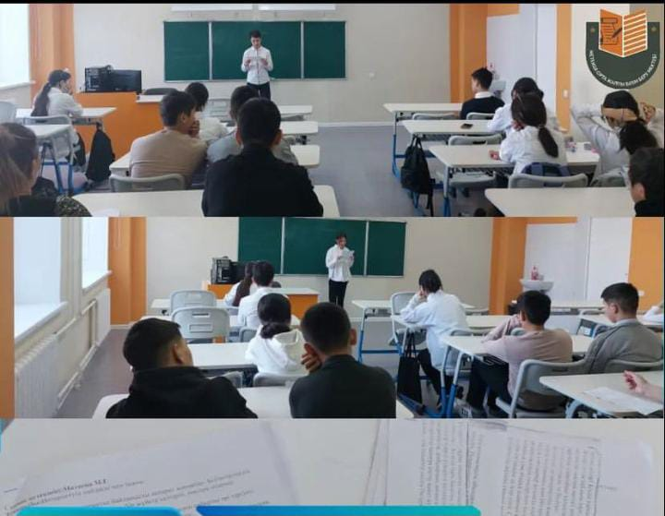

https://www.instagram.com/p/C4cV8ueN06C/?igsh=Z3M2eTloYWpmNXo0

[09:46, 28.03.2024] Aidana Matenova Психолог: https://www.instagram.com/reel/C4BCNINNYQz/?igsh=MW1najh5MmFnbWVwdg==

[09:48, 28.03.2024] Aidana Matenova Психолог: https://www.instagram.com/p/C34_xvFNGk9/?igsh=emZ2YjkxbjMxeDJ0

[09:52, 28.03.2024] Aidana Matenova Психолог: https://www.instagram.com/reel/C24IyiLtHLV/?igsh=MTF4YjZrdHZ2ZTdweA==

