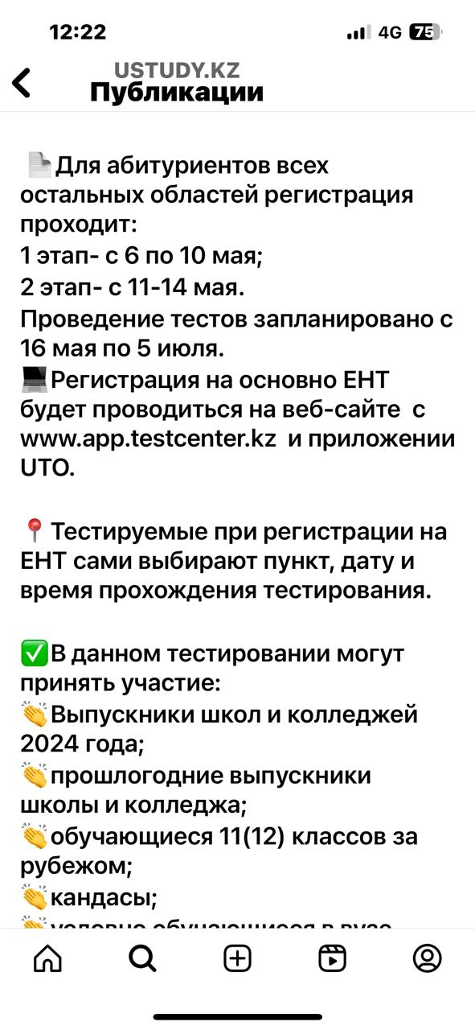
https://www.instagram.com/p/C6a4-VQs5Zi/?igsh=YjVtdHlxM3N1a2pu

